

RentCommend – Rental Assistant

Final Project Report

DT228

BSc in Computer Science

**Glenn Moore**

**C17390923**

**Mark Foley**

School of Computer Science

Technological University, Dublin

**31/03/2021**

Abstract

The rental crisis in Ireland is a situation which continues to spiral out of control. A recent estimate shows the national average rent currently stands at €1,122 per month, or roughly €1,620 if you choose to live in Dublin (MacNamee, 2018). Furthermore, it is estimated that apartments, which would be considered more than reasonable for a first-time renter, account for just 10% of Ireland’s household stock (Sullivan and Mcguckin, 2018). With costs continuing to rise and scarce availability of even the most basic of establishments, it is more and more difficult for people to make their first move away from the family home. With factors such as affordability, availability, and locality to work/college coming into play, it is becoming harder day by day to find a property to accommodate all the needs of an individual. The time is right for something to be done about this.

The goal for this project is to provide a simple, easy to use web application that will act as a rental assistant for those seeking accommodation. The application will be called RentCommend. The development of this web application will be centred around real-life potential users of the application, from initial research to final implementation of design choices.

The purpose of my project is to help people find the perfect property for them, listing available properties in a chosen area along with map widgets of local resources (e.g. price, location, transport network). The properties are then displayed in a list in order of how highly they score in terms of a user’s ideal needs. This gives the user an idea of what they have available to them in the area that is as close as possible to what they may need, allowing them to account for any compromises they may need to make on their list of requirements.

Hopefully RentCommend can make property hunting in Ireland easier for all users by displaying all the information they need in one place and make the transition into a new property as comfortable as possible.

Declaration

I hereby declare that the work described in this dissertation is, except where otherwise stated, entirely my own work and has not been submitted as an exercise for a degree at this or any other university.

Signed:



Glenn Moore

31/3/2021

Acknowledgements

I would like to thank my family and friends for all the help and support they have given me over the course of my studies, especially during what has been an extraordinary year. They have helped me on days that would have been much longer without their presence.

I would also like to thank my supervisor, Mark Foley, for all his guidance and support in the development of this application. Mark offered valuable advice and ideas in every project meeting we had and helped to define clear goals for what the application should accomplish. Any question was answered, no matter how big or how small, and the application would not be close to what it is today without his input.

Lastly, I would like to thank Alan Fahey and all my colleagues I have crossed paths with during my time as a Vocational Training student in SAP. Everyone in the company has been so welcoming from my first day, teaching me a lot about the industry as a whole and about myself and my capabilities. I am proud to have been an employee of a company who invested in me as a person and wanted to see me achieve my full potential.

Table of Contents

1. Introduction 6

1.1. Project Background 6

1.2. Project Description 7

1.3. Project Aims and Objectives 8

1.4. Project Scope 8

1.5. Thesis Roadmap 9

2. Literature Review 10

2.1. Introduction 10

2.2. Alternative Existing Solutions to Your Problem 10

2.2.1 Airbnb ……………………………………………………………………………………………………………………….10

2.2.2 Daft ……………………………………………………………………………………………………………………………11

2.2.3 MyHome …………….……………………………………………………………………………………………………..12

2.3. Technologies Researched………………………………………………………………………………………………………12

2.3.1 Programming Languages ……………………………………………………………………………………………12

2.3.2 Maps …………………………….……………………………………………………………………………………………13

2.3.3 Databases …………………….……………………………………………………………………………………………14

2.3.4 Containers ..………….……………………………………………………………………………………………………14

2.3.5 Cloud Providers ..………….……………………………………………………………………………………………14

2.4. Other Research you’ve done 16

2.4.1 Nielsen's Heuristics.………….……………………………………………………………………………16

2.4.2 User Centred Design.………..……………………………………………………………………………16

2.4.3 Students..………….………………………………………………………………………………………..…16

2.5. Existing Final Year Projects 17

2.6. Conclusions 18

3. RentCommend Design 20

3.1 Introduction 20

3.2. Software Methodology 20

3.3. Overview of System 22

3.3.1 Technical Architectures……..………….……………………………………………………………………………23

3.3.2 System Diagram….……...………….……………………………………………………………….…………………23

3.4. Front-End 24

3.4.1 Key Screens………………..……..………….……………………………………………………………………………24

3.4.2 Use Case Diagrams.…..……..………….……………………………………………………………………….……26

3.5. Middle-Tier 28

3.6. Back-End 29

3.7. Conclusions 31

4. Experiment Development ……………………………………………………………………………………………………………32

4.1. Introduction ………………………………………………………………………………………………………………………….32

4.2. Software Development …………………………………………………………………………………………………………32

4.3. Front-End ……………………………………………………………………………………………………………………………..32

4.4. Middle-Tier……………………………………………………………………………………………………………………………32

4.5. Back-End……………………………………………………………………………………………………………………………….32

4.6. Conclusions …………………………………………………………………………………………………………………………..32

5. Testing and Evaluation ……………………………………………………………………………………………………………..…32

5.1. Introduction ………………………………………………………………………………………………………………………...32

5.2. Software Evaluation ……………………………………………………………………………………………………………..32

5.3. Specific Evaluation ………………………………………………………………………………………………………….…….32

5.4. Questionnaires and Interviews Evaluation ……………………………………………………………………..…….32

5.5. Conclusions ……………………………………………………………………………………………………………..……………32

6. Conclusions and Future Work 32

6.1. Introduction 32

6.2. Conclusions 38

6.3. Future Work ……………………………..………………………………………………………………………………………….38

Bibliography 39

# Introduction

## Project Background

The rental crisis in Ireland is more evident now than it has ever been. With ever increasing costs, as well as a steady decline in the number of landlords currently renting out properties, we are witnessing a fall in supply when there is more demand than ever. In 2018, it was reported that there are roughly 30,000 empty homes in the Greater Dublin Area alone, with the local council having main ownership (Harris, 2018). In a county with a population of well over one million people, demand and rental prices would be eased dramatically if some of these properties were to be made available. Yet, prices continue to inflate as these properties lay empty.

Attempts have been made to combat this issue using technology. Many websites now exist to facilitate property listings, show detailed information on an area, and make it easier than ever before to find a roommate. Applications such as Airbnb have also added an element of competition in both the hospitality and housing sector, offering flexible alternatives to hotel stays and a new way for someone to house share or lodge without being tied down to a long-term lease. Technology may be the best short-term solution people have to what looks to be a long-term issue.

Although many applications exist for viewing information about what is currently available on the rental market, few bring together all the most important details in one easy-to-use place. This is the motivation behind the development of RentCommend.

## Project Description

RentCommend is a web application that acts as a property rental assistant for users to view available properties in a chosen area in Dublin in order of how well they meet their needs. Although the inspiration came from young people trying to live independently for the first time, RentCommend will be offer a highly positive user experience for users from all backgrounds and different levels of technological expertise.

What sets RentCommend apart from the average property website is rather than showing only properties that fall on or below the exact search criteria, the user sets how important each parameter is (Low, Medium, or High Priority). It will analyse all available listings, score them in relation to the priority for each parameter, and recommend an overall best match, along with some viable alternatives. For example, if the user sets house type as a higher priority than rental cost, and chooses a house as their property type, the system may recommend a property that is slightly over budget but matches their property type exactly. Due to the current rental crisis in Ireland, with many struggling to find properties that meet their needs, this application allows close alternatives to be shown to allow the users to consider any potential compromises they may have to make in their criteria in order to find matches that are as close as possible.

Each property also has detailed information such as its location on a map, photographs, and a filter to find all amenities within a given radius of the property, such as transport services, supermarkets, restaurants etc. This aims to allow the user to gain insight into everything they have available nearby if they were to choose this property. They can then save the listing as a favourite to their account to allow them to review all their best matches separately to the main listings page.

The complexity of RentCommend can be seen in the user experience. By offering all information about property listings in an area, locations of necessities in the surrounding area (public transport stops, supermarkets, restaurants etc), and a scoring system in order of how the user’s criteria is met, the user can see exactly what they need to help them make a very important decision in their lives. A big part of this project is that it has been tested by both those currently renting properties and those looking at taking their first steps into the rental sector. Feedback about potential features and improvements has come from those who are experiencing this crisis first-hand, showing the potential benefits of the use of this application by the public.

Communication with those currently renting or looking to rent was a paramount part of this project, as this application must offer an improvement to what they currently have available to them. Due to the pandemic and ongoing government restrictions, much of this feedback was gathered through virtual video conferences and online surveys, as opposed to physical demonstrations of the software.

The approach to this project included creating initial prototypes, distributing them to a suitably sized sample audience, gaining their feedback, and integrate any suggestions as well as my own ideas as features in the application. Repeating this process until completion of the project will ensure the development of a robust, easy-to-use application. Feature-driven development will allow for all new features to be integrated into the system as soon as they are working to a satisfactory level.

## Project Aims and Objectives

The aims and objectives for this project were as follows:

1. Identify and review suitable literature and other references relevant to this project
2. Describe some other software systems that are similar in nature to this project
3. Undertake a thorough design process, including a methodology and detailed design
4. Develop a working software system using suitable technologies
5. Test and Evaluate the RentCommend system after development
6. Critically reflect on the outcomes of this entire process

## Project Scope

The overall aim for this project is to provide a system for those looking to rent a property to see all available properties in an area in order of how close they meet their needs. It relates closely to the field of geospatial analytics, where analysis is performed on a chosen area regarding properties, facilities, transport links etc. The aim is to develop a modern, simple to use web application to help users find their ideal property to rent. The development of the application will be a fully user centred approach every step of the way, from initial research to final implementation of design choices.

A significant objective for this project is to have a scoring system for each property depending how well the user’s needs are met. This differs from current applications on the market as they set parameters with min/max values, like price and distance. If a user wanted to rent a property for no more than €1200 a month, it would only show available properties with a price less than or equal to that value. By having a scoring system, properties that are slightly more expensive could still appear highly in the search results if they meet many the user’s other needs. This gives the user some alternatives and an idea of any potential compromises they may need to make. This touches on the area of recommender systems in artificial intelligence and machine learning, where parameters are scored according to training data the model has analysed to assign appropriate scores.

Lastly, distance from other important locations can impact the decision of a user to move into a new area. Therefore, another aim of this application is to include a travel time calculator between two points. By mapping the road network, the user will be able to view how far they are away from work, college and other locations by car, public transport, cycling or even walking. This will help them view accessible their own network is from the potential rental property, and if they should consider a move.

Other potential ways of approaching this problem were considered that touched on other disciplines of computer science, such as using image processing to analyse overhead views of an area to determine features, or using augmented/virtual reality to have a virtual property tour etc. While these are viable solutions, the decision was made to focus on the disciplines of geospatial analytics and recommender systems to create a solution for the problem this project aims to solve in the most convenient and user-friendly way.

## Thesis Roadmap

This section will briefly summarize each of the chapters covered in this report.

Literature Review

This chapter explores background research related to property rental in Ireland, exploring some of the challenges involved with renting properties in Ireland, and the use of technology to aid the process for many tenants. A cross-examination will then be performed on existing property rental applications currently on the market. Finally, this chapter will discuss a variety of other research completed which has proven relevant for this project.

### Design

In this chapter, the choices behind the methodology chosen for this project are discussed. Detailed use-cases and personas related to the system will be presented and explained. Lastly, there will be discussions about the designed technical architectures and software testing plans for the project.

### Development

This chapter discusses the development process of the application. The implementation of use-cases and components of the application will be discussed, noting each feature of the application and the tools use to implement them. The decision-making process behind using certain tools to implement these features will also be explained.

### Testing and Evaluation

In this chapter, the testing and evaluation of the application will be discussed. The methods used to test the core functionality of each feature over the course of the project will be examined, as well as user testing from potential real users of the application to examine functionality as well as the overall user experience delivered.

### Conclusions and Future Work

This chapter reflects on the project in its entirety, noting what was successful about the finished product and any improvements that could have been made. It will also mention any future work planned for the development of the application.

## Literature Review

## 2.1. Introduction

In this chapter, some key areas of research that have been proven to be important in the development of this project will be discussed. These topics include exploring the current state of the rental market in Ireland, the use of technology in aiding the rental process for tenants, comparing existing property rental applications to examine their strengths and weaknesses, and the best ways to deliver an interactive and satisfactory user experience.

## 2.2. Alternative Existing Solutions to Your Problem

There are existing apps currently on the market to aid prospective tenants find the ideal property to rent. Due to the current state of the rental market in Ireland, it is of upmost importance that these apps are well researched and contain all features a user needs to aid the rental process. If an app is missing these features, there is a risk of tenants renting properties that will not accommodate their needs in the long run.

The following are web applications that currently exist to help users find the ideal property for them:

2.2.1 Airbnb

Airbnb, Inc. is an American online rental marketplace which allows people to list their properties for lodging, homestays or for tourism purposes. It was founded in 2008 and is based on the idea of allowing users to rent accommodation from other homeowners on a primarily short-term basis, offering an alternative to hotels and hostels in the hospitality sector.

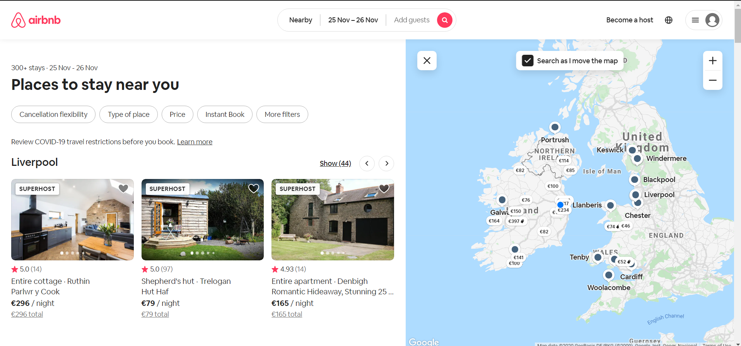

*Figure 1 – Airbnb listings screenshot*

Airbnb offers an intuitive and easy to use web application. There is a plain and simple colour scheme along with a minimalistic user interface, allowing those with even a low level of technological expertise to navigate through it without an issue. The user can select properties for specified dates and filter based on parameters such as price, number of bedrooms and cancellation flexibility. It offers a pay per night pricing scheme, avoiding the user being tied to a long-term lease.

This application is relevant to my project as it succeeds in solving a small part of the larger issue at hand. Although the application is a nice flexible alternative to standard rental, its focus is on short term rental as opposed to long term or student accommodation. It has also noted that Airbnb may be causing more harm than good to the rental sector by taking away some of the housing supply. (Lima, 2019) Therefore, it is not a complete solution to the task at large.

2.2.2 Daft

Daft is an Irish property website created in 1997. It allows users to register as either a landlord or a tenant, allowing searches for properties to buy, to rent, house shares, commercial spaces to let and more. Parameters including price, location and length of lease can be inputted, with a list of available properties then displayed along with contact information for the seller.

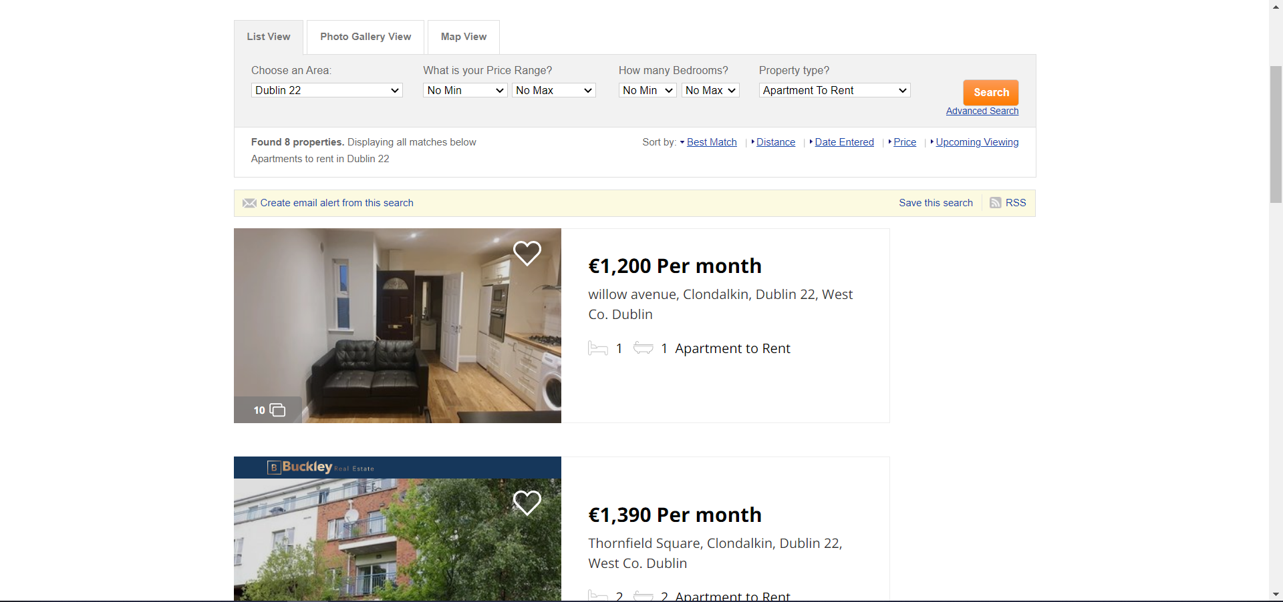

*Figure 2 – Daft property listings*

The user can view the properties available to them as a list, photo gallery, or map view. They can add a property they like to their favourites, as well as create an email alert for their search to get regular updates on properties meeting their criteria. They can also sort the properties by price, distance from a location, or the best match to their requirements.

Daft is relevant to this project as it includes some impressive features to convey information to the user. The user can view the locations of properties on a map, get email alerts of new properties that meet their search criteria, as well as see the best match to their search. However, this still depends on the parameters they include, as anything outside of these parameters will not be shown. This project aims to refine this feature by including close alternatives to certain parameters if the rest of the user’s search criteria is met, making them aware of compromises they may need to make.

2.2.3 MyHome

MyHome is an Irish online property platform founded in 2001. Like Daft, it allows users to search for properties to buy, to rent, home shares, commercial properties and more. Users can also list their own properties on the site, acting as a landlord. Users input search criteria such as price, location, and house type to get their list of results.

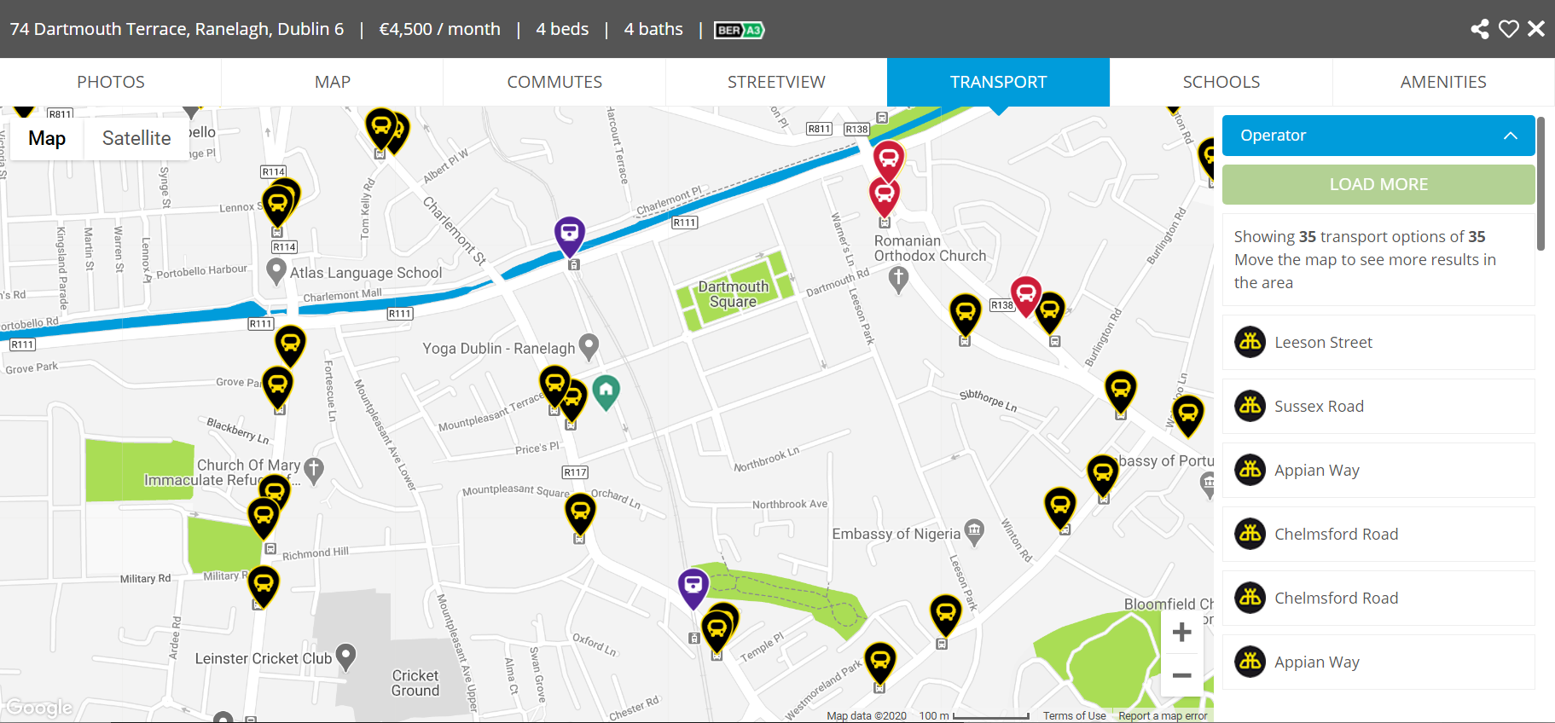

*Figure 3 – MyHome transport links around property*

MyHome differs from other property sites in terms of the level of detail provided for each property. Along with a standard map view, the user can see nearby transport stops, schools, and amenities in the local area. They can also get detailed information about how to commute to their chosen location by bike, car, walking or transit. This is relevant to this project as it ties into the principle of giving the user as much information as possible within the site itself. By the time the user makes an enquiry, they will know that the property meets their search criteria. The aim of this project is to expand on this information and create a recommender system based on how closely the property information meets the user’s search criteria, giving them best matches and close alternatives.

## 2.3. Technologies Researched

Much research went into the use of different programming languages, frameworks, and other technologies to aid the implementation of this project. Work from past modules, studying of documentation and reaching out to other lecturers aided the selection of the following:

2.3.1 Programming Languages

### Python

Python is an object-oriented programming language first conceived by Guido van Rossum in the late 1980s. Due to its clean syntax and versatility, it has climbed the ranks of the most popular programming languages rankings in recent years, even ranking as high as second in some cases (O’Grady, 2020).

Python is known for being one of the easiest programming languages to learn, with simplified syntax to make it more naturally readable. Over the years, the community has grown larger, and hundreds of libraries have been launched to aid development time. The versatility of Python has made it very useful in areas such as machine learning, data science, and server-side web development. The factors mentioned have seen the Python language adopted by many large companies like Google, Apple, and Facebook.

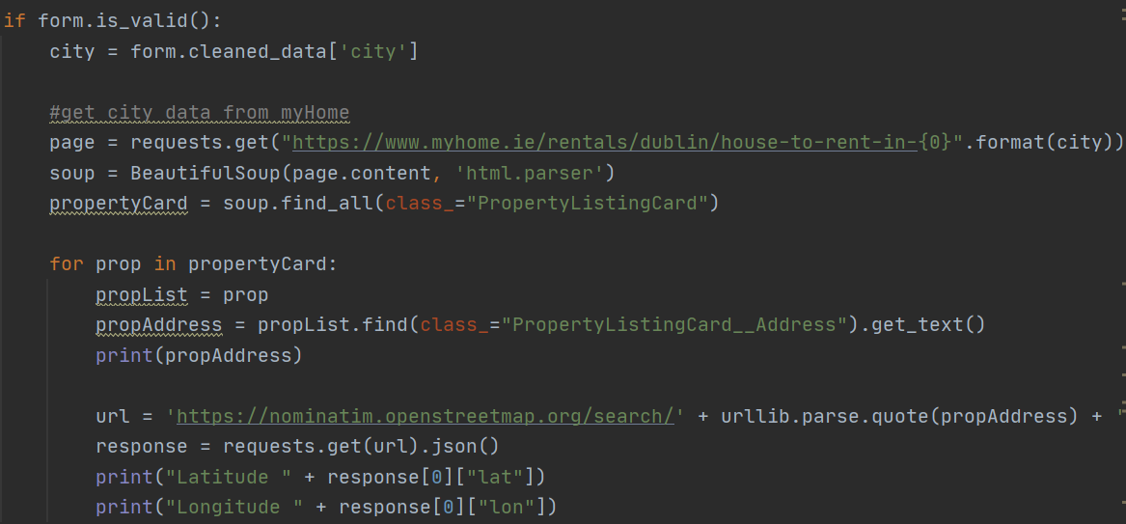

*Figure 4 – Python sample code with the BeautifulSoup library for HTML parsing*

After studying Python for the past number of years in different modules and learning the true power of the language, the decision has been made to adopt this language as the main language in this project. The use of extensive libraries and shallow learning curve allows for new features and ideas to be implemented with ease.

*JavaScript*

JavaScript is a high-level, object-oriented scripting language used in the development of interactive applications for the World Wide Web. It was launched in late 1995 following numerous iterations. (speakingjs.com, n.d.). This language is popular due to its many frameworks and libraries for both front and back end, such as jQuery, React, Vue and NodeJS. Usage statistics show that JavaScript is used by over 97% of websites as a client-side language. (w3techs.com, 2021)

JavaScript was chosen for DOM manipulation in this project. By using JavaScript, content can be updated on the page without the need for a refresh or redirect, such as location markers on a map. By integrating JavaScript with the Leaflet library, meaningful mapping information based on location and search criteria can be rendered for the user in an easy-to-follow format.

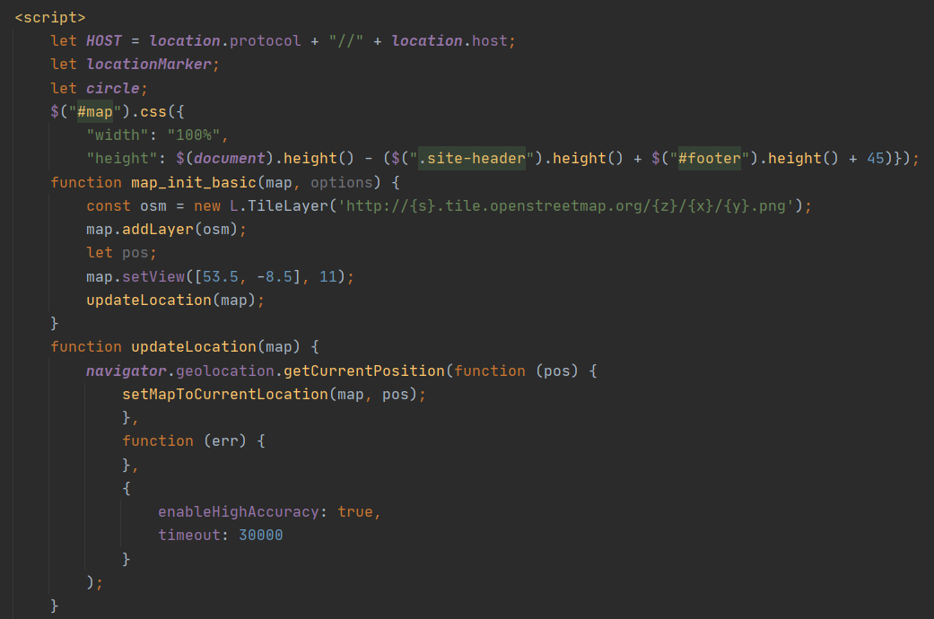

*Figure _ – JavaScript sample code using Leaflet to initialize a map on a page*

2.3.2 Maps

OpenStreetMap is a web mapping service developed in 2004 by Steve Coast. Free and open source, it is kept up to date by the OpenStreetMap Foundation to allow users to view and interact with geographical locations. (OpenStreetMap, n.d.)

OpenStreetMap has its own API to allow other applications to access its map data. Alternatively, it allows support from other APIs such as Overpass to interact with their maps. It also allows translation to the frontend of any web application by supporting tools like Leaflet. OpenStreetMap has been adopted by many large companies for their map features, including Facebook, Snapchat, and TripAdvisor.

As OpenStreetMap is a powerful tool that is both free and open source, it was adopted as the main mapping tool for this project. This tool will allow flexibility in the development of the planned mapping features.

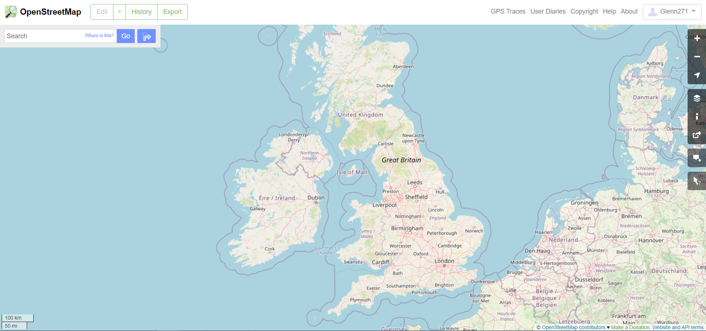

*Figure 5 – OpenStreetMap web tool for mapping and editing*

2.3.3 Databases

PostgreSQL is an open-source relational database. Initially developed in 1996, it focuses on SQL compliance and performance.

PostgreSQL does not have a limit on database size or on how many items can be stored in a table. Over the years, numerous libraries have been developed to enhance functionality beyond what was included in the native code. One such example is PostGIS, allowing geo data to be integrated. PostGIS allows input and output of GeoJSON data, which allows storage of geographic location data with ease (postgis.net, n.d.).

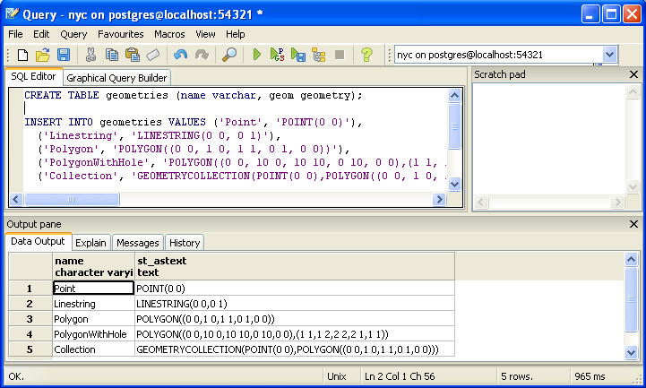

*Figure 6 – PostgreSQL sample code using the PostGIS extension*

By storing geographical data in a database, it allows this project to have less reliance of querying data from the web with every user interaction. It is for this reason that PostgreSQL was the database of choice for this project.

2.3.4 Containers

Docker is a set of platform as a service (PaaS) products which deliver small, lightweight applications and software in a package called a container. Initially launched in 2013, Docker has seen over 37 billion containerized applications downloaded since its release (Vaughan-Nichols, 2018).

Containers are a standardized unit of software that allow isolation of an application from its environment. By promoting application portability, it allows the application to run on almost any machine. It is said that Docker solves the age-old problem of “it works on my machine” (Docker, 2019). They are a good alternative to a virtual machine as the containers use a shared operating system (e.g Linux). Hardware therefore does not need to be virtualized, as they can rest on a single instance of the operating system.

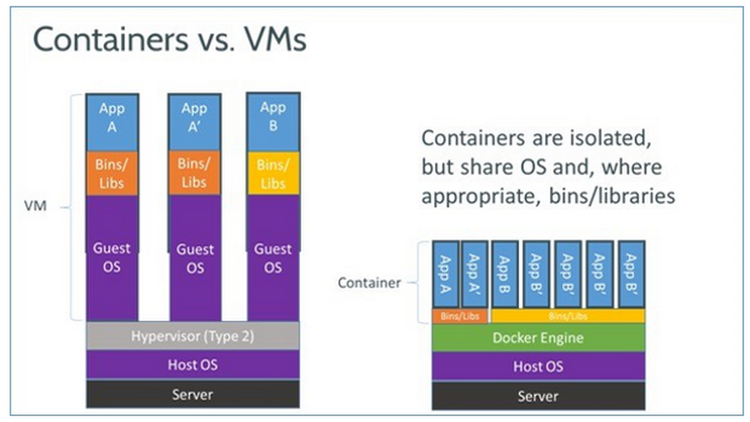

*Figure 7– Breakdown of resources used by virtual machine versus containers*

Due to the promotion of portability and sharing resources, Docker has been chosen to containerize components of this project. This will allow the application to work on as many machines as possible, while also using less resources in comparison to a standard virtual machine.

2.3.5 Cloud Providers

DigitalOcean is a cloud computing provider launched in 2012. It offers low cost hosting of services such as virtual machines and databases.

DigitalOcean offers virtual machines in the forms of droplets. A DigitalOcean droplet can run on a variety of Linux distributions like Ubuntu and Debian. (DigitalOcean, n.d). The advantage of these droplets is that Docker is preinstalled on these machines. This allows the creation of containers to manage PostGIS, Django and NGINX, among others. With fast deployment and availability of over 99.9%, it has proven to be a viable competitor to other solutions like AWS and Microsoft Azure.

DigitalOcean usage costs are very reasonable, with new users being offered $100 in free credit for the first 60 days. This coupled with the ease of deployment and high availability made it a viable technology for this project.

2.3.6 Application Programming Interfaces (API’s)

### Overpass

Overpass is an API from OpenStreetMap that offers read-only datasets of specified map data from OpenStreetMap (wiki.openstreetmap.org, n.d.). It uses a complex query language to allow users to find specific locations on a map, such as amenities, public transport links, and hospitality. The data is returned in the form of nodes (single points in space), ways (ordered list of nodes), and relations (group of elements consisting of one or more nodes, ways etc). Unlike the main OpenStreetMap API, Overpass is used specifically for querying view only data, which can then be passed to the frontend in ways such as a map. It also has support for programming languages in the form of wrappers such as OverPy for Python, which was used for this project due to the Python backend. Overpass was chosen to query nearby amenities in a specified radius around a property. This will allow the user to see the full range of services around their property should they choose to move in.

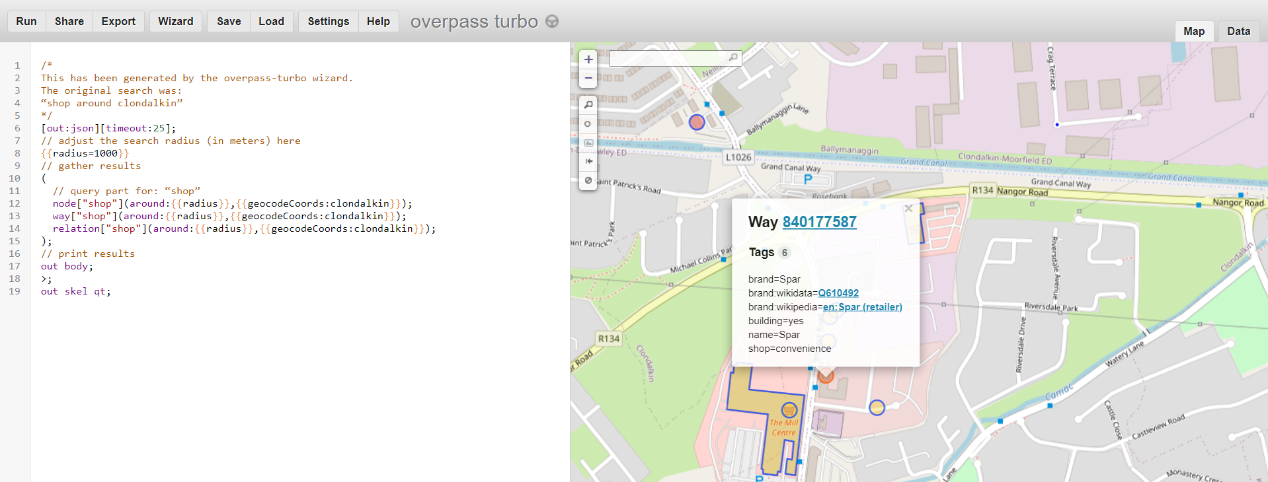

*Figure _– Sample Overpass query and output for shops in the Clondalkin area*

2.3.7 Responsive Design

Like all good web applications, one of the focus points for this project was to make the design of the page as simple and responsive as possible. The design must be intuitive to allow users to navigate through each page with relative ease and not be surprised with anything expected. There must also be rules in place for rendering content on devices with different interfaces and screen sizes, such as laptops, mobile phones, and tablets.

Bootstrap is an open-source CSS framework aimed at providing responsive design for both desktop and mobile web applications. It was initially launched in August 2011 as an open-source project, having previously been developed inside Twitter (Otto, 2011). Bootstrap was used for this project to ensure the application was easy to user regardless of the device used to access it, as well as allowing more focus to go into the core functionality of each feature over the front-end design and presentation.

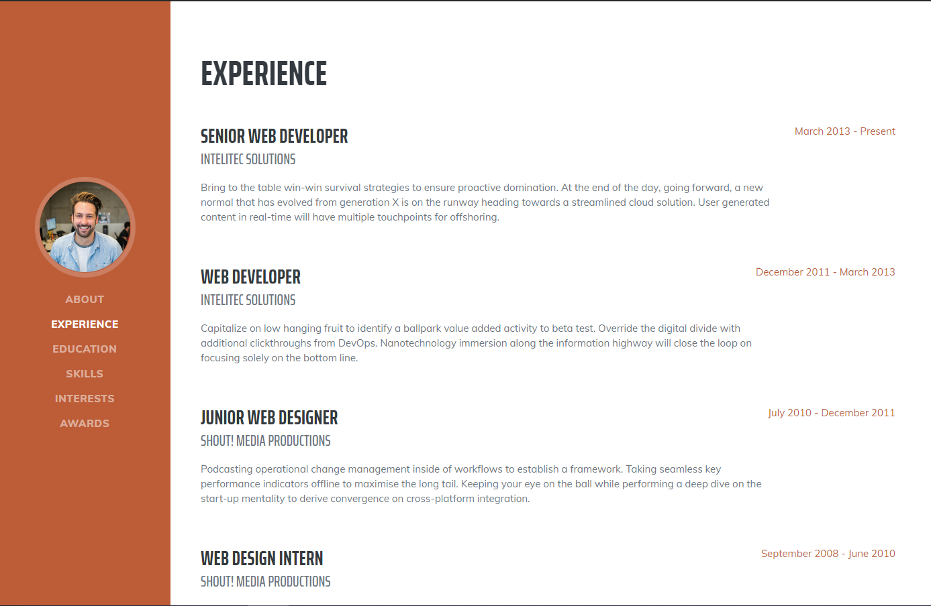

*Figure _– Sample Bootstrap template for an interactive CV*

## 2.4. Other Research I Have Done

2.4.1 Nielsen’s Heuristics

Nielsen’s Heuristics are a series of design principles for user interface design. Initially developed by Jakub Nielsen in 1990, these design principles have evolved to cover all the components an interface should have to be deemed as usable by all. Some characteristics of a good user interface design include simple and natural dialogue, minimizing the user’s memory load, and consistency. This will have the user feeling more confident in using the system, as they will already have part knowledge needed to operate new parts of the system (Nielsen 1994, p. 132).

In this project, maintaining a satisfactory user interface was of upmost importance. The application was developed to be as simple and intuitive to use as possible, even to those with low levels of technical expertise. The user will be able to revert to the main menu should they find themselves in unfamiliar territory, while also being continuously given feedback on what is happening on that page at any one time. This gives the app legitimacy as a real competitor to other applications currently on the market.

2.4.2 User Centred Design

User-centred design is an iterative design process which focuses on the needs of the user in each phase of the design process (The Interaction Design Foundation, n.d.). As this is an iterative process, any decisions and design solutions are constantly tested in how they compare to the initial user requirements. There are conflicting methods on how to implement user centred design in terms of cost-effectiveness and supportiveness of the initial ISO standard (Jacko 2003).

ISO 13407 defines user centred design as an approach which makes systems usable. User-centred systems are designed in a way that supports users and motivates them to learn. (ISO, 1999). By conducting studies into what exactly users require in a rental assistant and renting property in general, this application was carefully developed with the user’s main concerns in mind. This will allow users to be encouraged to try RentCommend and explore the full scope of the application’s functionality.

2.4.3 Students

One of the main reasons a young person would rent for the first time is to acquire student accommodation for third-level education. In Ireland, students are faced with renting accommodation in close proximity to the campus at a high cost or commuting long distances every day to their respective institution, often leading to fatigue and burnout very early into the semester. With negative effects on the person’s physical and mental health, it often leads to difficulties for the student to commit to their studies in first year and beyond. (Daniels, Sheahan and MacNeela, 2019).

The HEA reports that the availability of accommodation on campus versus the demand for beds leaves an unmet demand of over 25,000 (HEA, 2017). This unmet demand has a direct impact on the private rental sector, as students need an appropriate place to live near the campus. With costs every increasing, students are also left to juggle their studies with work responsibilities and their social lives, leaving less time for sleep. (Martin et al., 2012).

This application aims to help the user find a property which meets their location and budgetary needs as closely as possible. Having all this information in one place will allow the user to decide if they will feasibly be able to afford renting the property and know if their academic needs will be met.

## 2.5. Existing Final Year Projects

During the research phase of this project, several Final Year Projects from previous years were studied. These projects held some relevance for the features to be implemented in the RentCommend system.

*CrimeViz: Irish Crime Data Visualization - Max Curtis*

The purpose of this web application is to allow for visualization of Ireland’s crime statistics in their current state. The user can input their chosen area and year and see a breakdown of the statistics for their chosen search criteria. The project allows the information to be conveyed in an easy-to-view manner through a straightforward UI containing a geographical map. This information is useful for those who want to check crime rates in an area before they move in, or for the authorities to monitor crime trends in areas in recent years.

Complex parts of the project included displaying these statistics on an interactive user map. Tying the data in the background into a meaningful frontend must be considered for it to be understood. Mapping the overall crime data of Ireland to each Garda Station in the country was also complex, as two separate datasets needed to be mapped together into one, along with testing needed to

This project used OpenStreetMap, Leaflet, GeoJSON, PostgreSQL, AWS, NGINX and Django.

A key strength of this project was the ability to map the overall crime statistics of the country to individual towns and cities, making it convenient for people to view trends in their own areas or indeed an area they would consider moving to. This is relevant to my project as it includes similar functionality to display some important background information about an area on a map like this, to allow users to gather as much knowledge as possible about the area around a property before moving any further into the rental process.

*The Relocate Mate - Darren Mc Cole*

The purpose of this web application is to aid relocating to a new area when searching for a new job. Important factors such as cost of living and available amenities are taken into consideration to recommend cities to move to, as well as the average salary for different occupations in the chosen area. This app displays data for three countries – Ireland, England, and Canada.

A complex part of this project was the maintenance of data from three different countries, as most applications of this nature tend to stick to just one. A great deal of work would be involved to make sure all information is correct and consistent. However, this gave the website room to expand to a wider range of users.

The application uses technologies such as Python, Django, PostgreSQL, Apache, and HTML/CSS.

A key strength of this project was how it compared the cost of living in an area in line with salaries for different occupations. This would aid an individual in managing their finances by seeing how much of their salary would go into funding their accommodation. Budget is a key factor in property rental, and a similar feature to show how a property can cater for a persons financial situation has been implemented in RentCommend.

## 2.6. Conclusions

Having gained knowledge on the private rental sector in Ireland and the current crisis, the development stage of the application commenced. A clearer understanding of the problems prospective tenants face when they go to rent a property, as well as the information they currently have available to them allowed the true scope of this project to be uncovered.

After discussions with fellow students and friends who currently rent and the process behind securing a property, an idea was conceived for what the ideal property rental app should look like. A list of potential features was developed, as well as a rank of how important their inclusion would be, from high to low priority.

After putting a list of features together, the technologies best suited for this project were decided on.

Requirements Table

|  |  |  |
| --- | --- | --- |
| **Name** | **Description** | **Priority** |
| User Login | Allows the user to login to the system. | HIGH |
| User Logout | Allows the user to logout of the system. | HIGH |
| User Registration | Allows the user to create an account on the system using their chosen credentials. | HIGH |
| User Update Details | Allows the user to edit their personal details at any time to ensure they are correct and up to date. | HIGH |
| Property Search Screen | Provide a screen for the user to input search criteria for a property. | HIGH |
| Map Widget for Properties | User can see the results of their property search in the form of location markers for each property that matches their criteria. | HIGH |
| Scoring System for Ranking Properties | Display properties in order of how closely the user’s criteria has been met. The property that is the best match appears first, with alternatives displaying underneath. | HIGH |
| Location Markers for Nearby Facilities | Display all facilities in the surrounding area of the property (transport stops, shopping centres, restaurants etc) | MEDIUM |
| Travel time calculator | Display travel distance from one location to another (the actual road route as opposed to straight line distance). | MEDIUM |
| Notification System | Weekly roundup of properties that match criteria e.g. in-app notification, email sign-up | LOW |
| Add to Favourites | Allow users to add properties to a favourites list to view at a later stage. | LOW |

# 3. RentCommend Design

## 3.1 Introduction

Following on from the previous chapter, where key background research for the project was presented, some of these themes will continue in this chapter where the design of the application will be presented. Firstly, the software methodologies employed in this project will be discussed, including the reason why the decision was made on which methodology to use. Use-cases and user personas will then be presented to describe how the typical user may interact with the system. The next section will give an overview of the technical architecture, discussing front-end, back-end and other aspects involved in allowing the system to work as desired. Lastly, there will be a discussion of the plan for testing and evaluating the system.

## 3.2. Software Methodology

Waterfall Methodology

The waterfall methodology is a linear, sequential approach to software development. The project is broken into stages that are completed one by one. Once a stage has been completed, developers cannot return to a previous stage. They must either see the project through to completion or start the whole project from the beginning (Base36.com, 2013).

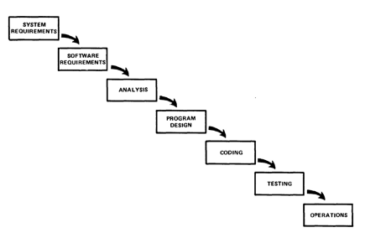

*Figure 8 – Waterfall Methodoology*

Benefits of the waterfall methodology include having a clear idea of the project scope, aiding project management, and high levels of documentation. However, waterfall makes changes very difficult to implement. A working piece of software is not delivered until close to the end of the development cycle, which would not work with the feature driven development approach taken for this project. As testing occurs last, if something goes wrong in the project, it is necessary to go back to the very start to resolve the issue. As continuous user testing is a large factor in this project, combined with testing coming last in this methodology, waterfall would not make sense to implement in the development of RentCommend.

V Model

The V Model is an extension of the idea of the waterfall methodology with a more user centred approach. The user needs start on the left, a piece of software is developed in the middle, and user validation occurs to create the finished product on the right. This gives a “V” shape structure to the development cycle. This gives an alternate concept that determines the best solution for the user’s needs. (Forsberg and Mooz, 1991).

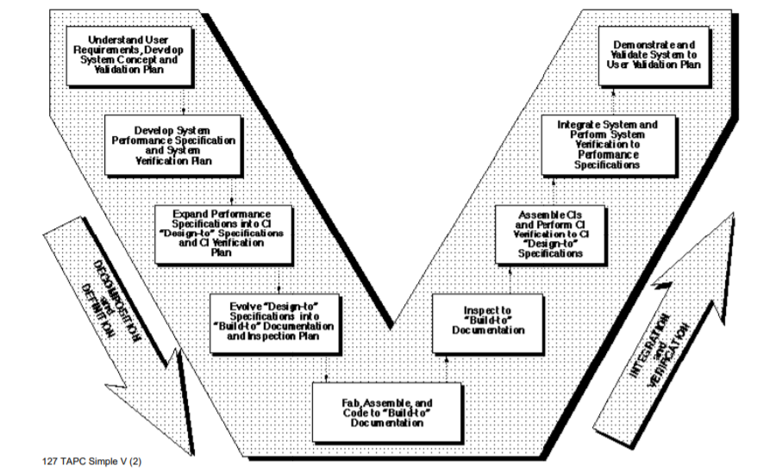

*Figure 9 – V Model overview*

While this is an improvement on the waterfall methodology, it still has some pitfalls that make it unsuitable for this project. Testing does not take place until a working solution is created or almost complete. This would not compliment the feature driven approach to developing this project. It would also mean the project would have to go back to the beginning if issues were found late into the development cycle. For these reasons, V model would not be a suitable methodology for RentCommend.

Agile Methodology

The agile methodology follows an incremental approach to software development. With Agile, the developer can be more flexible with the development of the project. In this methodology, the plan for the system is broken up into smaller components called “sprints”. Each of these sprints will last a specified amount of time, normally two weeks. At the end of a sprint, re-evaluation of the project priorities occurs and the plan for development of the system is altered accordingly. It allows projects to have a non-linear plan of attack as well as promoting customer collaboration, effective teamwork, and responsiveness to change (Muslihat, 2018).

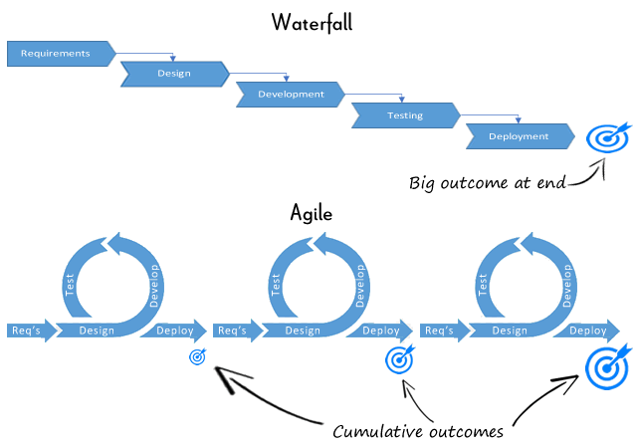

*Figure 10 – breakdown of Waterfall vs Agile methodologies*

This methodology is well suited for this project as many changes are expected to occur during the implementation phase. Testing can also continuously occur, allowing bugs to be caught during development and design choices to be made as I go. Agile also adds a higher level of user focus than other methodologies, allowing feedback to occur after each feature is implemented to ensure the project is consistently up to standard.

## 3.3. Overview of System

The development of this system occured with a feature driven approach in mind. Feature driven development (FDD) involves planning a feature, implementing it, and testing as part of a sprint. Only when this feature is implemented does the next feature begin to be developed. As this is an Agile method, it greatly compliments the software development methodology chosen for this project. FDD works for long-term, complex projects such as RentCommend, which aided the development process over the course of the academic year.

Rather than completing the full design before coding begins, design and code were delivered in stages. Each feature was researched thoroughly before implementation began. This allowed for quick adaptation to any changes in project requirements or new developments in the private rental sector over the course of the year.

The plan for development of the project was conceived as follows:

1. Implement basic version of the application including login, registration, and simple property search. Ensure layers are communicating with each other as desired.
2. Design a feature (e.g. displaying properties in order of how they meet entered parameters).
3. Implement the feature.
4. Test the feature.
5. Repeat steps 2-4 implementing all desired features – implement in order of priority checklist.

3.3.1 Technical Architectures

The technical architecture shows the layers in this application and how they communicate with one another. For this project, a 3-tier architecture was chosen. The client tier is where the user will interact with the application, a web browser in this case. The application tier is where the application is hosted, being able to take in requests from the client and issue responses from the application server. The data tier is where the database is housed. The application tier can query the database for results, the database tier returns the queries to the application tier to issue back to the client. This architecture was chosen as it keeps the logic of the application separated between tiers.

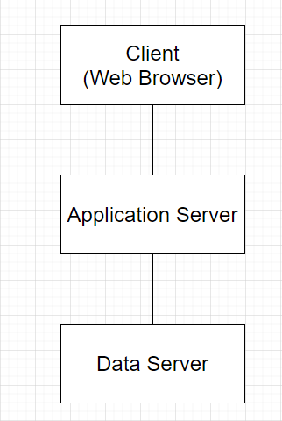

*Figure 11 - 3 Tier Architecture*

3.3.2 System Diagram

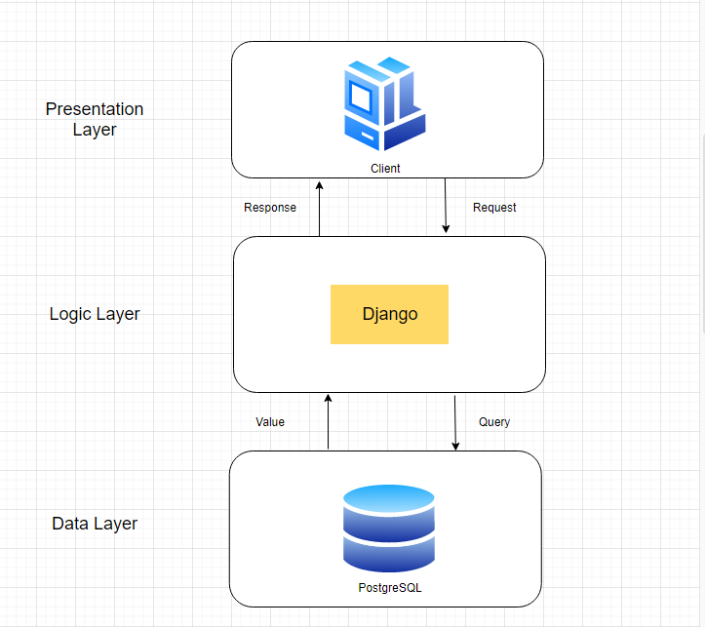

*Figure 12 - System Diagram*

## 3.4. Front-End

## 3.4.1 Key Screens

Firstly, paper prototypes were used in the design of the frontend. These paper prototypes were useful as they were convenient to make, could be sent on to potential users, and they gave a great idea of the potential finished product before a single line of code was written.

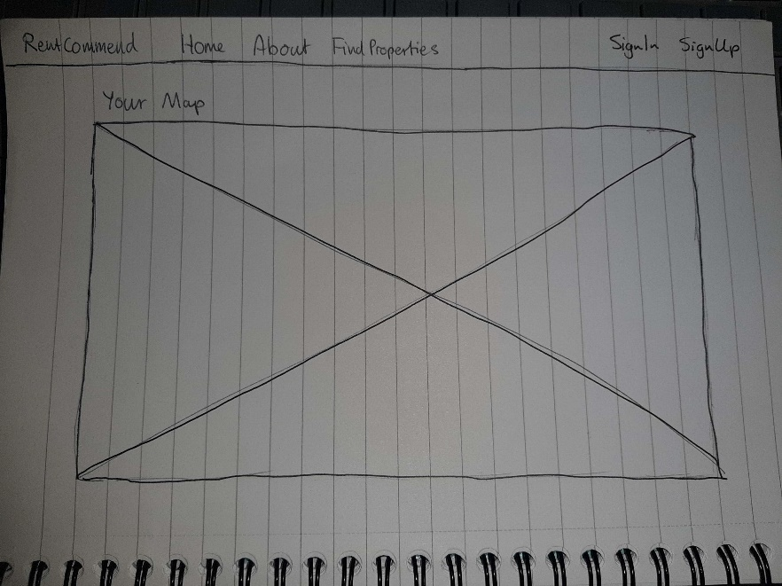

*Figure 13 – Home Page*

The home page displays the current user’s location on a map. It will give a basic introduction to the map functionality of the page, along with links for logging in, registering, and finding properties.

**\*add About Page prototype\***

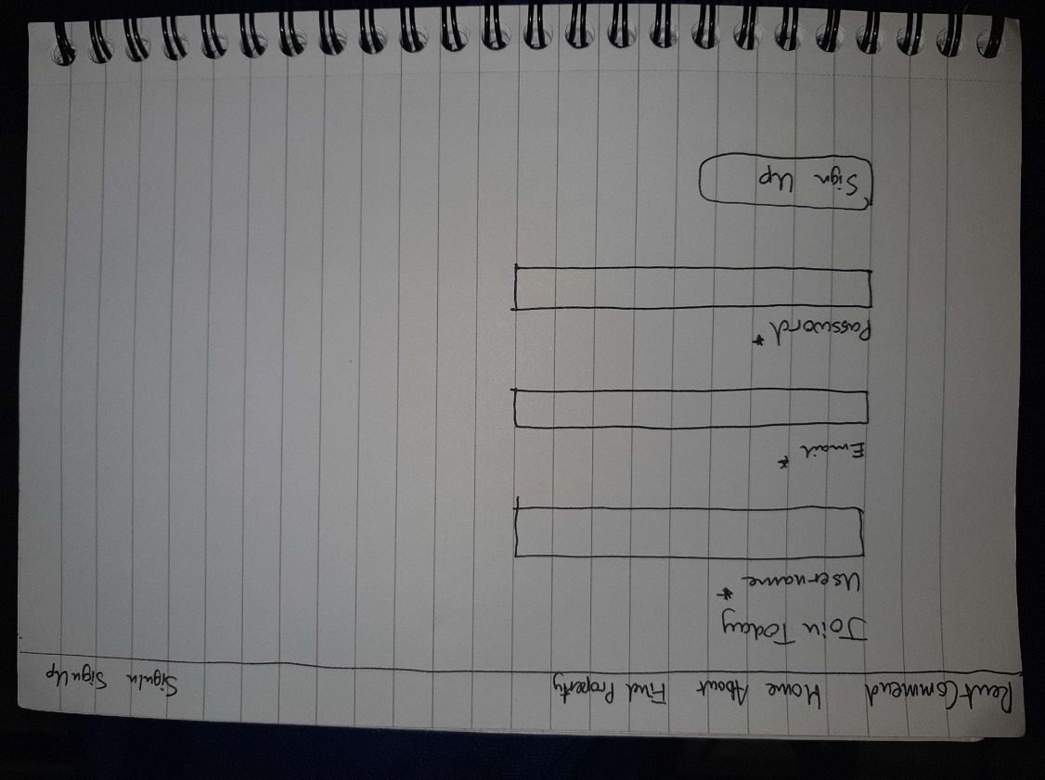

*Figure 14 – Sign Up page*

The register page allows the user to create an account should they not have one already. It takes in a unique username, email, and password as required arguments. Once a user has an account, they will be able to start saving favourite properties and their search parameters. However, an account is not needed to explore available properties.

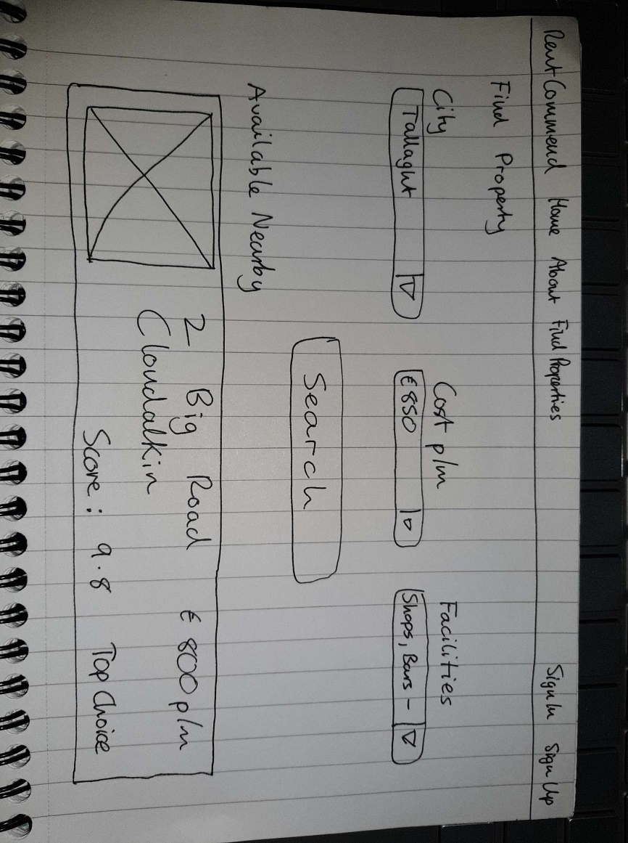

*Figure 15 – Find Property page*

The Find Property page will allow the user to find properties with their ideal search criteria. This includes the area/city, rental price, and a checklist of nearby facilities. The results will display in a list, with the property matching their parameters closest as a top choice.

The next stage of the screen layout design phase used a free online program called draw.io. This allowed for a high-level design of the layout of the screens and how they would operate.

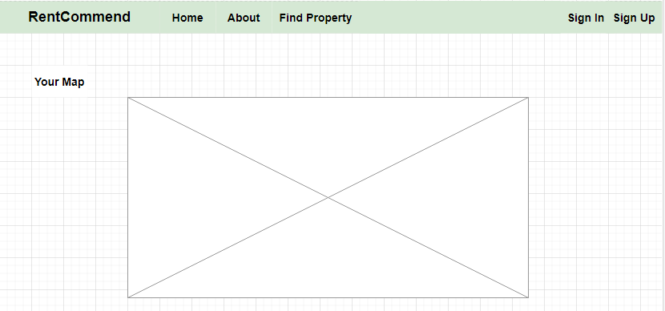

*Figure 16 – Home page*

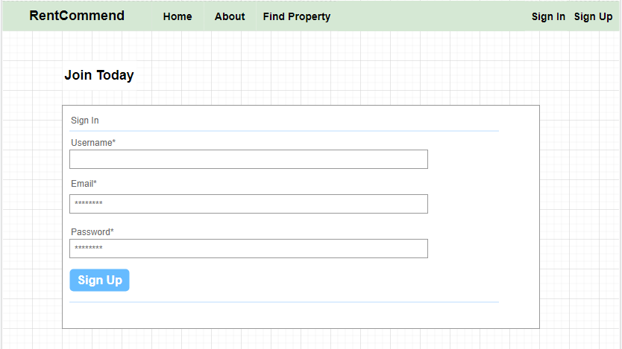

*Figure 17 – Sign Up page*

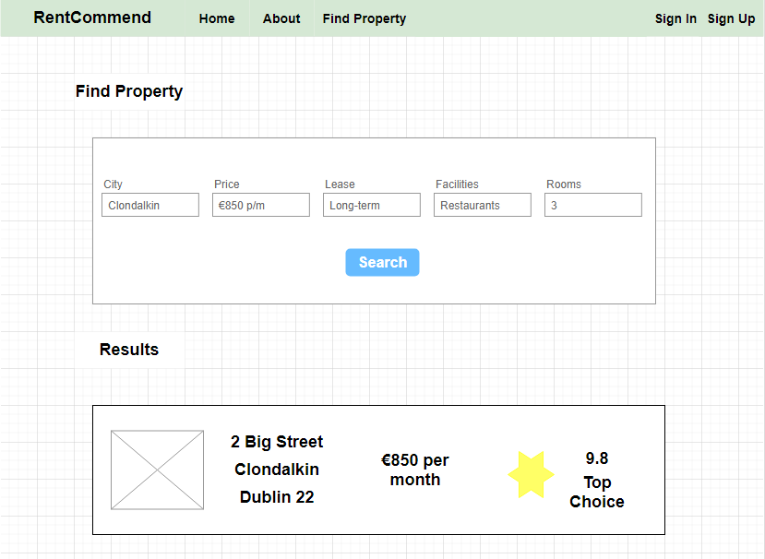

*Figure 18 – Find Property page*

## 3.4.2 Use Case Diagrams

This section describes the design of the user’s interaction with the RentCommend system. There are three key diagrams in total: the initial design, giving a simple overview of the system, followed by an intermediate design with further detail, and lastly, a final design with all key features included in the system.

The basic functionality of the system is as follows. The user can login or register for an account, view their location on a map, and log out whenever they wish. This design was incorporated in the initial prototype to confirm the database could store login details and ensure mapping functionality was accurate. The user does not need to create an account to use the system, but will need one for some more advanced features later in the system.

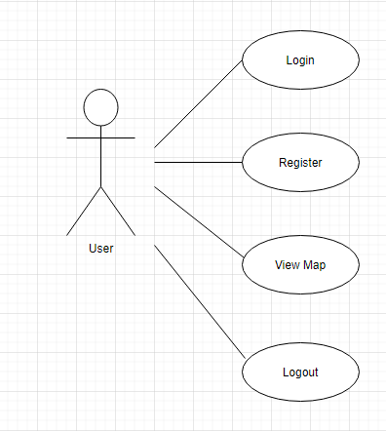

*Figure 19 – Initial Use Case Diagram*

The functionality of the system was then further developed. The user will be able to search for properties in an area of their choice, along with other parameters such as rental price and proximity to other locations. They will be then able to view the location of these properties on a map along with a popup with information about the address and rental price. This allows further analysis of available properties. Further functionality has been added to the login user case too, allowing users to view their profile and reset their password if it has been forgotten. These choices can be seen in the intermediate design below:

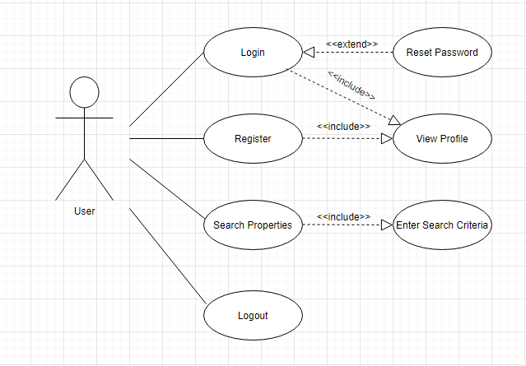

*Figure 20 – Intermediate Use Case Diagram*

The final implementation of the design will have more complex features. When the user searches for properties, they are presented with a few new options. They can view recommended properties in order of best matches, view nearby facilities such as restaurants and grocery stores, calculate travel times from the property to a desired location, and add the property to their favourites list. On their profile, they can also view notifications about potential new matches they may be interested in based on previously entered criteria. These choices were made to allow the user to view as much information as possible in one location rather than having to compare several pages at a time before making their decision, while also being well informed of properties that may be a good fit for them.

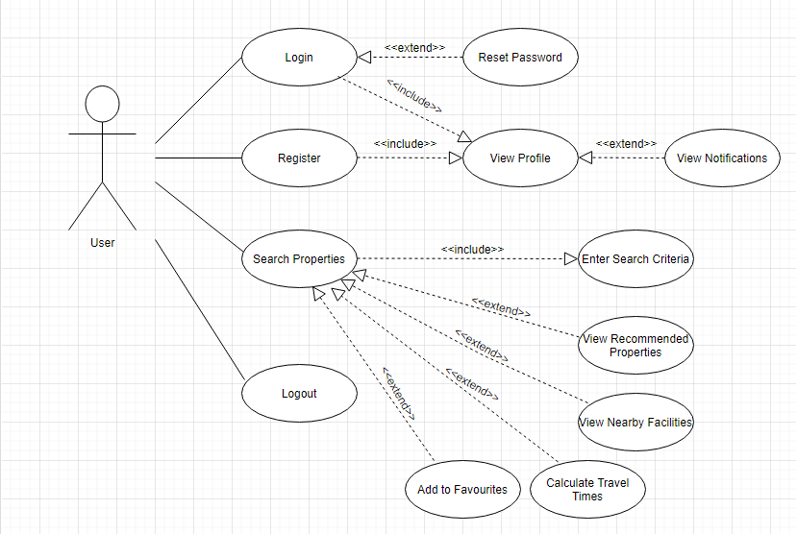

*Figure 21 – Final Use Case Diagram*

## 3.5. Middle-Tier

Django is a web application framework based on the Python programming language. Django is known for scalability, portability, and maintainability using its own implementation of the Model View Controller (MVC) design pattern.

Django decouples the frontend of a project from the backend through the default architecture it sets up when a project is made. Django uses the MTV (Model Template View) approach to a web application (Gour, 2019). Models are used to interact with data and databases. Templates provide a designer friendly templating system using plaintext. Views take in data from the model, formats the data as a HTTP response, and passes it on to the browser. A Django project can contain one or more Django apps, each designed to perform one piece of functionality well.

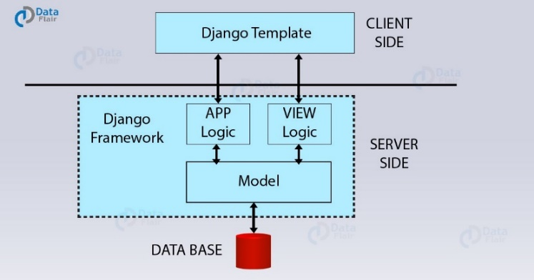

*Figure 22 – Django architecture between client and server*

After using Django for the Advanced Web Mapping module and experiencing how it eases the process of full-stack development, it has been chosen as the middle-tier for this project. By implementing several Django applications inside one project, along with decoupling the front-end from the back end, it will allow logic and functionality to be separated and ensure each application performs as desired.

## 3.6. Back-End

The data layer is made up of the data access layer and database storage structure. It is often accessed through the middle tier or logic layer.

As previously discussed, PostgreSQL will be used for data storage. The databases will be deployed in a Docker container on DigitalOcean to allow for remote database access.

The design process for the database schema went through several phases. Firstly, the user structure was designed. A User is comprised of a username (unique identifier, making it suitable to be a primary key), email, and password, all provided during the registration process. The idea was to have the user provide simple credentials to begin with to allow testing of the login functionality.

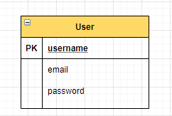

*Figure 23 – ERD Iteration 1*

The next iteration of the ERD focused on adding property information. A standard rental property is comprised of an address, town/city, rental price, latitude, and longitude. Every property will contain these basics, regardless of the type of property or size. This information allowed initial mapping of properties on a map to take place.

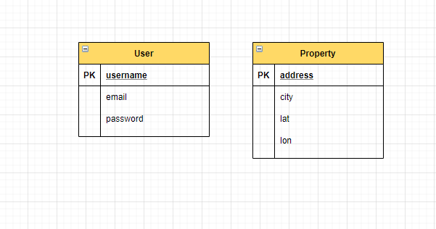

*Figure 24 – ERD Iteration 2*

The final iteration of the ERD involved adding more specific information about properties to allow potential recommending to the user. A new table, UserNeeds, will reference the User table, and contain information on the ideal property the user would like. This includes rental price limit, ideal location, proximity to location (in kilometres), and lease type, with potential for more parameters. The property table has been updated to include extra parameters like number of bedrooms/bathrooms and lease type. This will allow for recommendations to begin to occur for the user, where the user needs can be compared to what is currently available on the market to prioritize properties that match the user’s ideal property as closely as possible.

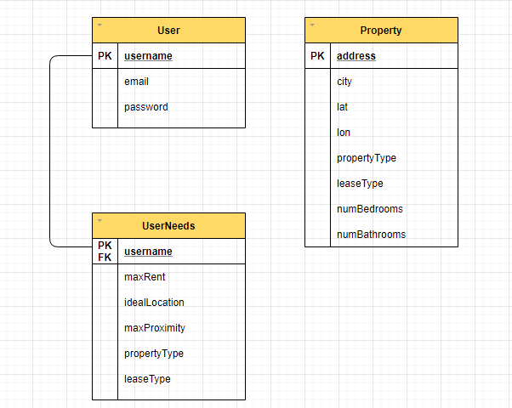

*Figure 25 – ERD Iteration Final*

## 3.7. Conclusions

In this chapter, the design of the RentCommend system was presented. First, the Agile methodology was discussed as the approach to be used in this project. Following this, the technical architecture of the system was presented, and in this case, the 3-tier architecture is being used.

The front-end design process of the system was presented next, with paper prototypes, wireframe prototypes and Use Case diagrams to help document the evolution of thinking about the user interface. The middle tier was discussed, focusing on the use of Django. Lastly, the back-end was discussed, with Class Diagrams to show the design of the objects, and Entity Relationship Diagrams for the tables.

# 4. Experiment Development

## 4.1. Introduction

This chapter focuses on building upon the key design concepts identified in the previous chapter, as well as the technical implementation of these concepts. Key features of the system will be identified, accompanied by the code needed to implement them. This chapter is divided into sections of development, with each section referring to a different component in the system architecture. The Front-End section will examine the user interface and what steps were taken to ensure an intuitive, simple design. The Middle-Tier section will focus on how the Django framework was used to effectively link the front-facing application the user sees and the logic occurring in the background. The Back-End section will examine how data was gathered, stored, processed, and returned for display in a clean and readable manner.

## 4.2. Software Development

The development of the RentCommend system took place over the course of the entire year. The development process was split into two phases. The prototype phase involved outlining the core functionality and high priority features of the application, before putting together a prototype version that illustrated the key concepts.

4.2.1. Prototype Development

The GitHub repository for this project can be found at ([https://github.com/Glenn271/Moore-Glenn-C17390923-DT228.git](https://github.com/Glenn271/Moore-Glenn-C17390923-DT228)).

A basic prototype was developed towards the end of the first semester in order to explore the approach to user login and registration, along with some basic mapping components. The user was initially brought to a default home screen to show them their current location on a map. This allowed an initial implementation of Leaflet along with incorporating OpenStreetMap.

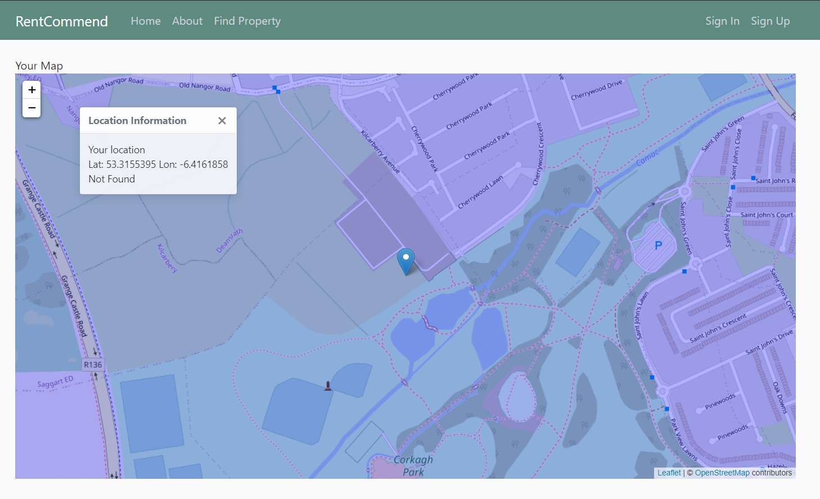

*Figure 26 – RentCommend prototype home screen*

From here, the ability to search for a property was facilitated through a link in the navbar. The user at the time was able to choose one of several sample cities in the dropdown menu. When they selected a location, BeautifulSoup would scrape raw HTML data for current listings on the Irish property market and displayed them on the results page. Location markers on the map will show where each property was located, with a popup message containing the address and rent cost appearing when the marker was clicked. A full list of properties was also visible below the map in cards rendered using CSS and Javascript. Implementing this feature allowed a simple introduction to BeautifulSoup, as well as how to pass context data from the view to be rendered on the frontend template.

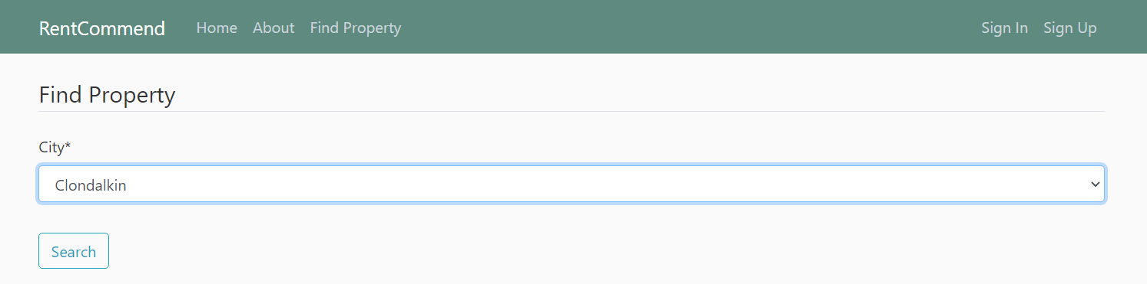

*Figure 27 – RentCommend prototype search screen*

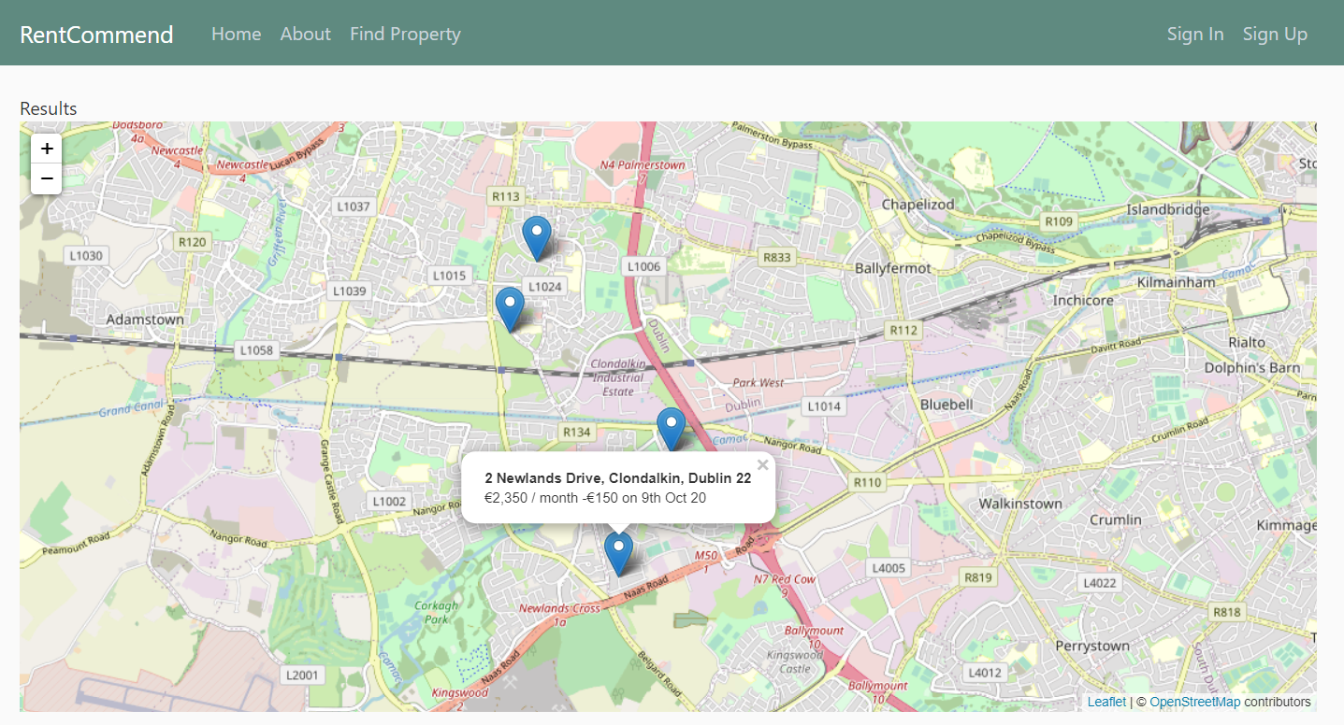 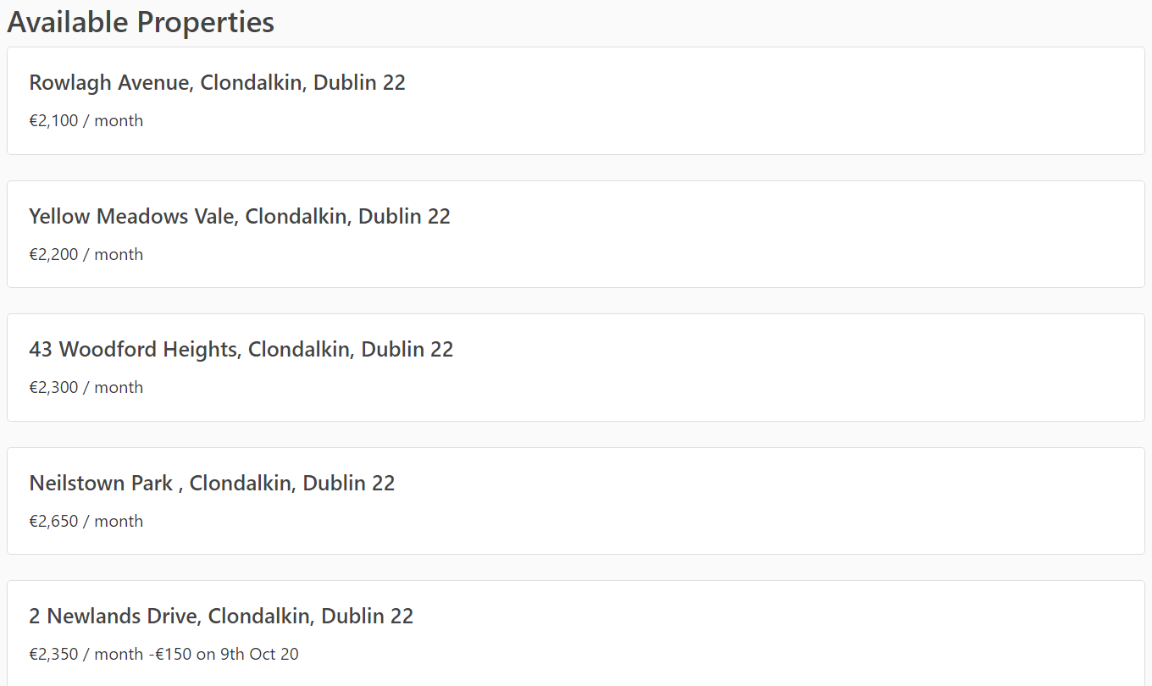

*Figure 28 – RentCommend prototype results screens*

The last feature of this prototype was the ability to login to an existing account or register as a new user. This was achieved using PostgreSQL and PgAdmin, a management tool for PostgreSQL. The registration form was created using the Django Crispy Forms library to allow the creation and management of forms with ease. It declared constraints such as password length, email being in a valid format, and not allowing for the username and password to be too similar. This handled most of the validation that would otherwise have to be manually developed in the backend, giving a secure registration system and a smaller code base to maintain. This feature allowed a strong login and registration system to be present early on in the development cycle, with the code remaining largely the same in the production version of the application.

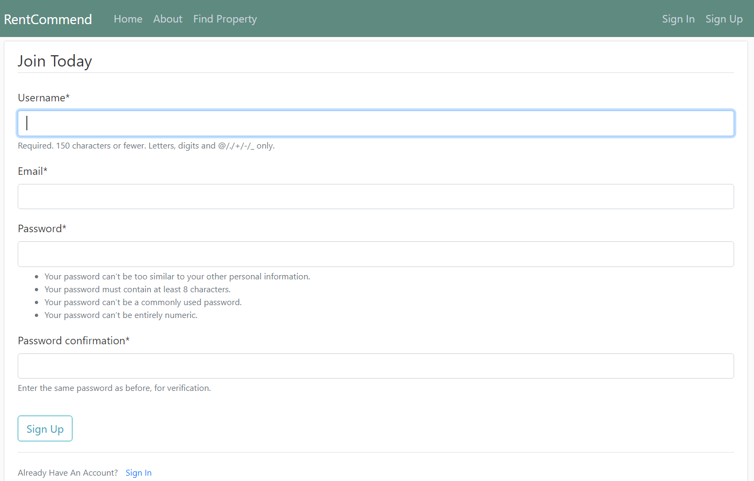

*Figure 29 – RentCommend prototype registration screen*

The development of the prototype allowed the creation of a solid foundation for the application, giving the project a clear sense of direction as to where it could go next. As many Python libraries were used for the first time, it gave an opportunity to study the documentation in detail and to learn how they functioned through practical examples. Having a strong understanding of these libraries early in the development cycle allowed for the quick expansion of the prototype features once development resumed after the winter exams.

The largest obstacle encountered in the development of the prototype was the sourcing of reliable, detailed property data. Enquiries to several property websites were made to obtain access to datasets or APIs that could aid the sourcing of property information. However, such tools are only available to be used in a commercial environment only. Once BeautifulSoup was identified to manually obtain this data, the next goal was to store the data locally and represent the content on the front-end in a meaningful way.

4.2.2. Production Development

Once the prototype was complete and the winter exams came to an end, development resumed on the production version of the application. The production version of the system expanded upon the key concepts in the prototype, as well as introducing some newer features to make the system look and feel like a real-world property application.

*Multi Criteria Evaluation*

The first major change from the prototype version of the application was the introduction of multi criteria evaluation when searching for properties. Multi criteria evaluation uses a weighted sum technique to evaluate a given problem based on a selection of criteria. A simple MCE algorithm involves giving a standardisation of criteria scores, allocating weights for the importance of a given criteria, and applying the algorithm to gain an overall score of the problem. This principle is mainly seen in location analysis in geographical information systems, to determine how suitable an area of land may be based on different factors (Jiang and Eastman, 2000).

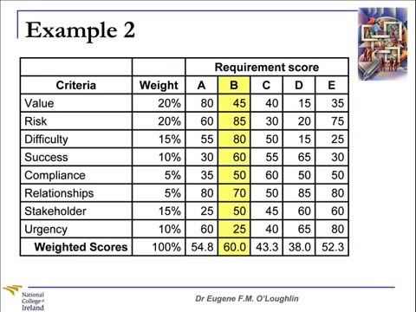

*Figure _ - An example of weighted scoring in multi criteria evaluation*

A version of this weighted scoring was adopted for this project. Four criteria are considered when searching for a property – the property rental price per month, type of property (apartment, house, or studio), number of bedrooms, and number of bathrooms. The user uses the search page form to enter their ideal maximum rental price, ideal property type, and ideal number of bedrooms and bathrooms. They then use the priority sliders to assign how important each of these parameters are to them, from low to high. For example, a user may want only properties with a maximum rental price of €1500 per month, not concerned about the property type or number of bedrooms and bathrooms. By setting the rental price priority to high and other priorities to low, the system will implement the multi criteria evaluation algorithm to display all available properties in the area in relation to how closely they match the user’s budget. The user can equally set everything to be of an equal priority, in which case the algorithm will balance the weighting and display the properties in order of what may be a more general match for the user overall.

The implementation of multi-criteria evaluation in the application helped to achieve the initial goal of RentCommend, which was to encourage the user to consider being flexible on some of their criteria to gain a property that matched their needs as closely as possible. Multi-criteria evaluation implemented this principle of having some parameters not be an exact match to the user’s needs to recommend an overall best match for them. There were some initial struggles around the standardization of criterion scoring and how to balance the user’s allocated weights to always equal to one. However, these struggles were quickly overcome, and added to the finished application for the better.

*User Favourites*

One addition to the application late in the development cycle was the ability to add a property listing to a favourites list on the user’s profile. This allows the user to create a list of potential properties that may suit their needs and review them at a later stage to make a final decision. Initially identified as a low priority feature, it eventually switched to medium priority due to the improvement to the overall user experience once implemented. It also became a higher priority due to the account creation feature having little meaningful use without the favourites feature being present.

This was perhaps one of the most challenging aspects of the project. It required a high level of understanding of the relationship between a user and a profile. The Django model also needed to be altered to have a field that held an instance of a property being favourited by a user. Some issues in the implementation process included making the relationship one to one instead of many to many, which initially resulted in a property only being able to be favourited by one user at a time. After studying of the Django documentation and altering of the model, this issue was eventually solved and allowed multiple users to add multiple properties to their favourites list. The addition of the favourites feature received very positive user feedback, and succeeded in making RentCommend feel more complete in comparison to existing property applications.

*Nearby Amenities*

The production version of RentCommend included the ability to find all amenities within a given radius to a chosen property. The system used the Overpass API and OverPy Python wrapper to query amenities in a radius inputted by the user, from 500 meters to 5 kilometres. The amenities are split into categories like Food and Drink, Education, Transport, Financial Services, Healthcare, Entertainment and Shops, along with miscellaneous locations that fell outside these categories.

Using Overpass helped to create a meaningful visualisation of all services and amenities the user would have available to them should they move into the relevant property. This feature did take some time to implement due to the complex query language of Overpass requiring a substantial amount of documentation reading to fully understand. Implementing this feature also involved learning how to gather and classify the data in a meaningful way on the front-end. If the project were to be completed again, this feature would have been implemented earlier in the development cycle, with more time dedicated to studying the documentation before going into the code. Despite this, Overpass was a successful addition to the project.

## 4.3. Front-End

This section expands upon the methods used for the final development of the web application. The functionality of each page of the application will be examined. As Django was used as the framework for the system, the front-end of the system was accomplished using the templating system in the Model Template View approach. As this application is a progressive web app, it can effectively be used on any system with a suitable browser, making it suitable for both desktop and mobile devices. The application can be added to the home screen of the mobile device to function as if it had been downloaded from the App Store or Google Play. This approach ensured that only one code base needed to be written and maintained, as opposed to implementing the same functionality in an environment like Android Studio. More time could be dedicated to implementing each feature once and implementing it to a high standard.

## 4.3.1 Base

The templating system of Django allows the application to focus on a single web page approach. The base.html file acts as a parent to all other pages created in the application. It contains all content that will be consistent across each page (for example, the navigation bar, links to log in/log out to the user’s profile), eliminating the need to rewrite the same information repeatedly by allowing each child page to inherit the base page content where needed. Tags are used to define the head and body content from the base.html template for rendering.

## 4.4. Middle-Tier

## 4.5. Back-End

## 4.6. Conclusions

# 5. Testing and Evaluation

# 5.1. Introduction

This chapter discusses how system functionality was effectively tested and examined to create a well-functioning web application. Due to the high level of user interaction required in RentCommend, user testing was conducted to gain meaningful feedback from potential real users of the system. The system will also be evaluated in this chapter, giving a breakdown of the criteria that was met to make a final decision on how successful the project was.

# 5.2. System Testing

Several different testing methods were used when testing the RentCommend application. The core functionality of the backend was tested locally, to ensure the database was set up correctly and that all URLs were correctly registered and directed to where they needed to go. The user experience side of the application was considered, with methods put in place to allow users to examine the functionality and report any issues they may have had.

5.2.1. Testing Approaches

*Unit Testing*

Unit testing is the method of testing individual units or components of a piece of software to confirm they function as expected. This may relate to an individual object, function, or procedure in the code. Unit testing allows for modular testing of units in the project without waiting for other features to be completed or implemented. It also allows code to be refactored at a later stage, ensuring the original test case still works as it did at an earlier point of time in the development process. (www.guru99.com, n.d.)

Due to the feature driven development approach undertaken for this project, only when one feature is tested and implemented does another begin to be developed. As unit testing does not depend on other features to be implemented to test an individual component, it allowed each feature to be tested as it was developed, as well as having room to refactor the code at a later stage when any necessary changes were made. It was for this reason that unit testing was chosen as the testing approach for this project.

5.2.2. Testing Frameworks

Several testing frameworks were considered as part of the testing process. Each framework was measured in terms of the learning curve to use it and how closely it matched the required testing outcomes of this project.

*Selenium*

Selenium is a portable framework used for software testing. It allows automated tests to be written in a variety of languages to run against most modern web browsers.

The idea behind Selenium is to allow for automation for web browsers. The WebDriver API controls the browser and allows tests to be run on the deployed application. The IDE offers the development of test cases, recording the actions of users in the browser as these tests are being run (Selenium, n.d.). This allows for easy testing of the application every time a new feature is implemented, without having to manually examine the functionality every time. The Selenium Grid allows for running several tests on different machines at the same time, allowing for checking functionality across platforms.

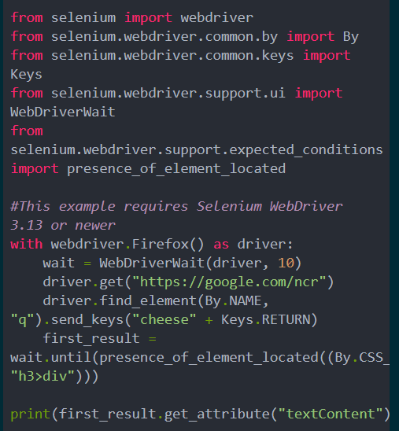

*Figure _ – A simple test case using Selenium for Python*

With each new iteration of the application, Selenium can be used to step through a testing plan step by step with a single click. As Selenium can be used with many languages, it remains a viable option even if the main development language is changed. However, it was decided that since the main page content was being heavily tested by real users as part of the user experience evaluation, more time could be devoted to unit testing individual components in the front, middle and back end instead of learning how to automate browser testing from scratch. For this reason, Selenium was not chosen as the testing framework for this project.

*Django Test Framework*

As this application uses Django, another option that was considered was using the built-in test framework from Django. Built upon the standard Python *unittest* library, it provides a platform to create automated tests to save time, prevent issues it identifies from occurring, and makes code appear more attractive and trustworthy. (docs.djangoproject.com, n.d.)

The Django test framework helps to identify issues in both the model (database content) and view (front end code the user interacts with). It can help assert that values for a model object are logically correct and appear as expected, along with creating a test environment to make sure the correct content is found at a given URL. It can also test the validity of a Django form by allowing tests to fail or pass as expected based on the content the user enters (leaving a required field empty should return false, the maximum length of a field is set correctly, making sure the user can only select from a dropdown etc).

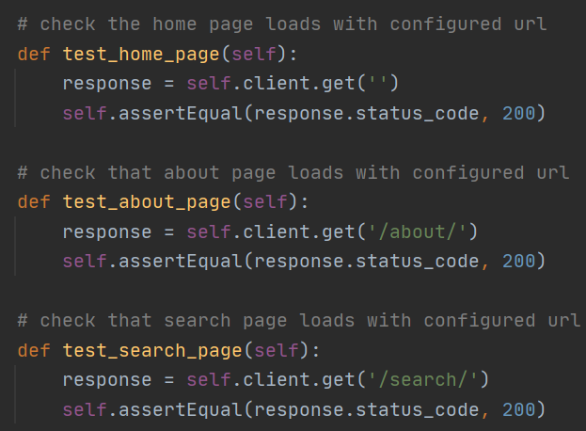

*Figure _ – Test cases for Django views to ensure URLs are correctly configured*

Due to relative ease of use and existing of top of the *unittest* framework for Python, the Django test framework heavily complimented the unit testing approach to this project. Therefore, it was chosen as the testing framework for RentCommend.

5.2.3. Testing Plan

An important aspect of the testing process was the testing plan. A testing plan describes the scope of testing, the features to be tested, entry/exit criteria and more. It is important to be able to test the application to make sure one new feature does not suddenly inhibit the functionality of other features.

As Django was chosen for this project, it was necessary to test if model objects, form data, and view components would work as expected. The following plan was created for unit testing the project:

|  |  |  |
| --- | --- | --- |
| **Test Name** | **Description** | **Input** |
| Housing Model Creation | Can a new listing be created successfully, with each field functioning as expected? | Housing object |
| Housing __str__ Method | Does a property listing return the address of the property as configured in the __str__ method? | Housing object |
| Housing Absolute URL | Does a Housing model object successfully generate a URL to the listing as a DetailView? | Housing  object |
| Housing URL Max Length | Does the Housing model field for image url correctly configure a maximum length of 300, to ensure an image url is fully stored and not cut off too early? | Housing  object |
| Property Search Form Labels | Do the labels for fields in the property search form render as configured? | Property Search Form |
| Property Search Form Area Required | Will the system recognise if the required field Area in the search form is left blank? | Property Search Form |
| Property Search Form Property Type | Will the system know if the user has inputted an invalid option for Property Type? (i.e., not present in dropdown) | Property Search Form |
| World App View URL Configuration | Are the URLs configured correctly for the world application and return a status 200 code as expected? | World View URLs |
| Property Detail View URL | Will the URL configuration for a DetailView of a listing correspond to a newly created listing and return a status 200 code as expected? | Housing object, World View URLs |

5.2.4. Unit Testing

Once the testing plan was established, a range of tests were written using the Django test framework. These tests were written to ensure the code written for model, view and form components was of a high standard, as well as making sure the system could correctly identify if a field did not behave as expected.

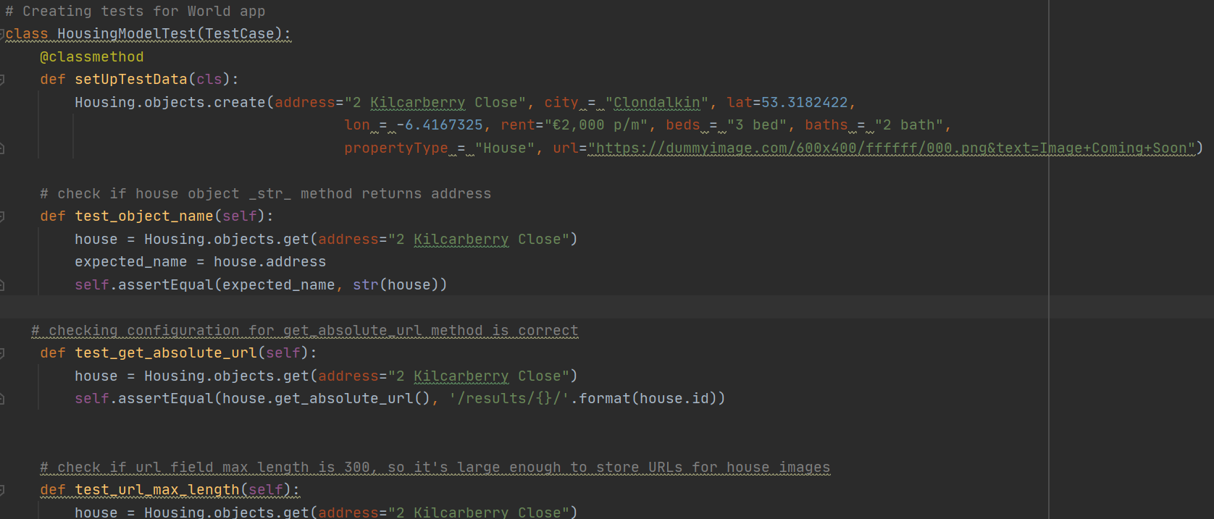

*Figure _ – Unit tests for the Housing model*

Testing the Housing model involved creating a sample property listing, with fields set to behave as they should in the main application. Testing of the custom __str__ and absolute_url methods occurred, which was of high importance due to the overwriting of the default methods, meaning the custom methods should behave to a similarly high standard. The housing image URL was also tested to ensure that the max length for the field was long enough to store a complete image URL, and not return an invalid image.

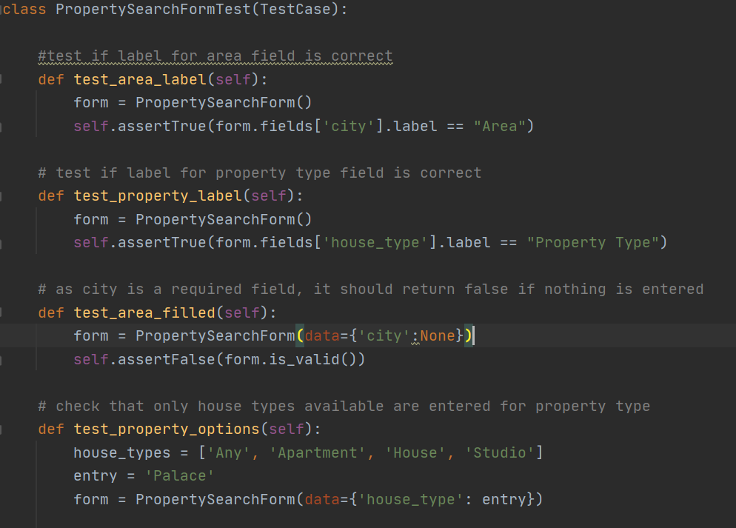

*Figure _ – Test cases for the property search form*

The property search form was tested to ensure that required fields could not be left blank, along with confirming that users could not choose any options other than what appeared to them on screen. This was to ensure that the recommendation had a strict set of criteria to analyse and would be able to identify anything it was not meant to see. This in turn made sure that the multi-criteria evaluation was accurate for the user to view their top recommended properties based on the criteria they inputted.

Lastly, the URLs configured for many templates and views on the page were tested to ensure that when visited, they displayed a successful status 200 code and rendered the correct content. This was done to ensure that the flow of the application was clear and consistent, a clear pathway to every page existed, and that content that was meant to be seen by the user was able to be accessed.

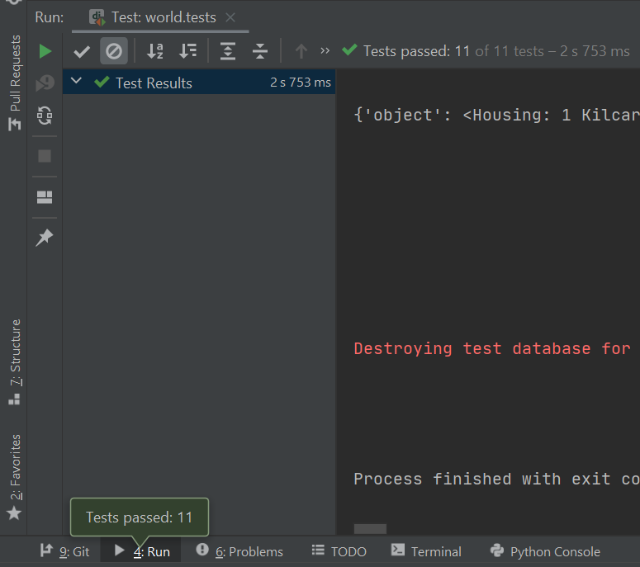

*Figure _ – Successful running of tests for the World application*

The testing code was then run to ensure that every test written returned a pass. This confirmed that all test cases were written correctly to ensure that the code written was of a high standard and did not contain any inconsistencies.

5.2.5. User Testing and Evaluation

As previously mentioned, testing from real potential users of the system was a substantial part of this project. As many users in the test group either were currently renting a property, or looking to move out for the first time, it was important to compare RentCommend to other property websites they may have used to ensure the system behaved in a manner they expected. Suggestions from users were also taken on board for potential other features or fixes, to emphasise how RentCommend could offer something different to existing software.

To begin the user testing, a beta version of the application was created. This version of RentCommend contained much of the core functionality of the application, such as account creation, property searching, and finding amenities. The beta evaluation of the system was conducted to ensure that the existing code was stable and did not throw any unexpected errors. The evaluation also aimed to identify what could be done to make the system flow more naturally from start to finish and ensure that all content was displayed in a user-friendly manner.

Next, a test group was identified. The group was constructed to include people of various age groups, along with different levels of technical ability, to ensure that the application was useable by as large of a demographic as possible. Out of 20 participants, the age range was 20-67. Participants ranged from graduates employed in the I.T sector, to retired individuals who casually use the internet for basics like instant messaging and email. More than half of the group were either currently renting or had rented a property at least once. This spread ensured that the evaluation was not biased by age or technical ability, and the concerns or suggestions of any individual were accounted for equally.

An anonymous user survey was then created and distributed to the group accompanied by a link to the beta version of the application. Questions included satisfaction ratings for ease of navigation, look and feel of the webpage, and checkboxes for the number of pages they were able to access.

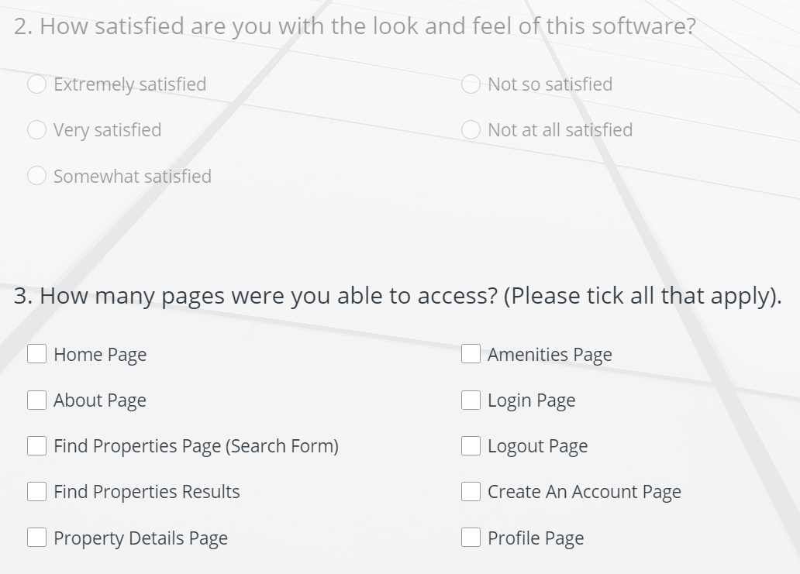

*Figure _ – Sample of questions from user evaluation survey.*

Users were also given the opportunity to add if they had issues accessing any content on the page. This included adding the site to their home screen on mobile, errors when searching for properties and amenities, and overall comments about their experience. After a beta period of 4 days, results were gathered and analysed.

Overall, the beta feedback was very positive, with most users being able to interact with the website to a satisfactory level. The answers ranged from positive to mixed, with little to no negatives reported. Users were able to create an account, search for properties, and view all nearby amenities. This evaluation allowed confirmation that the existing code base was solid and robust for handling errors.

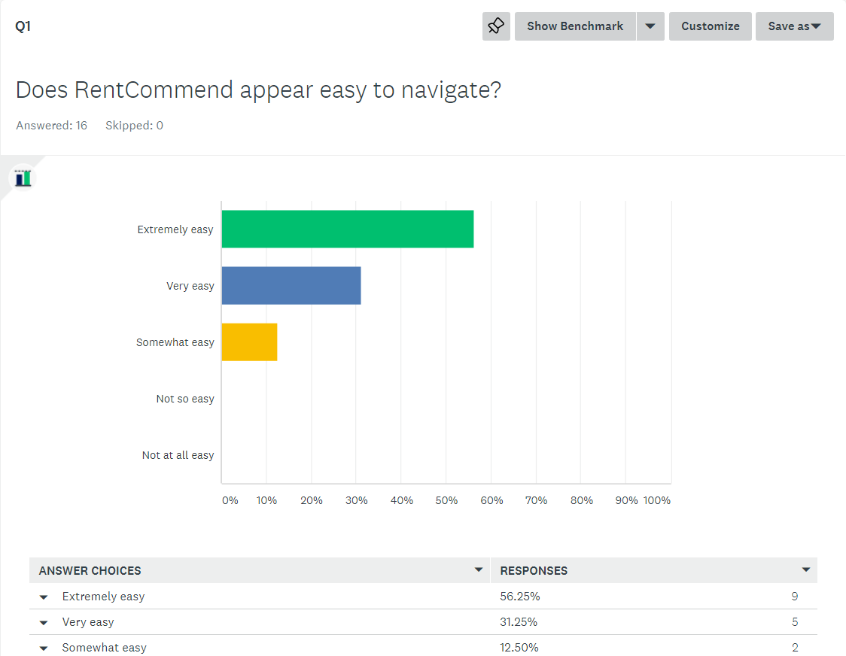

*Figure _ – User feedback for the navigation of the application*

The main feedback gained from users related to the user interface of the application and the user experience. This included some inconsistencies such as the amenity results not being centered on the property, layout of elements on the page, and the rendering of content on the mobile version of the application sometimes being too small or clunky. The evaluation helped to identify these overlooked issues, and fixes were implemented in the final version of the application.

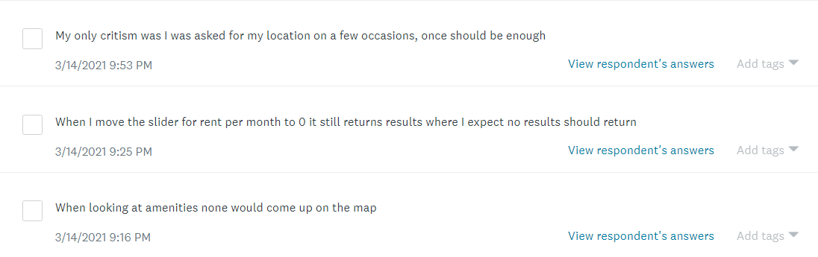

*Figure _ – Issues reported by users*

The user evaluation also helped to identify and prioritise what other features could be implemented during the remainder of the development process. As the submission deadline began to approach, it became important to focus on features that would improve the user experience the most. After the evaluation process was completed, it was clear that there was an overwhelming demand to have an option to add a listing to a favourites section. This would allow the user to gather a list of suitable properties and view them separately at a later stage. This was originally identified as a low priority feature to implement, but soon became clear that it would have a greater impact on the overall user experience than other features that may have been planned with a higher priority to complete. Due to user demand, the favourites feature was fully implemented into the final version of the system.

Allowing users to test and evaluate the application with a manageable amount of time before the submission deadline was a decision that worked well in the evaluation of this application. It allowed users to find any issues or inconsistencies that may have been overlooked in the initial development stage, give meaningful feedback on the user experience, and suggest any features they would like to see in the final version. The final application included significant improvements to the user experience, user interface, and the addition of a highly requested feature, successfully implemented due to the clear goals identified in the user evaluation phase.

## 

## 5.3. System Evaluation

## While user testing and evaluation played a large part in the project, it was also important to evaluate other aspects of the application to deem the project as a success. This included measuring the performance of the application, how it adhered to best practises, and overall accessibility.

*Google Lighthouse*

Google Lighthouse is an open-source, automated tool used to measure the quality of web pages. It allows any web page to be audited for performance, accessibility, search engine optimization, and best practises, along with validating the aspects of a progressive web app (Google Developers, 2019). It also offers flexibility by running the audit in the Chrome DevTools, from the command line, or as a Node module.

Once the final application was deployed, the website was audited on both desktop and mobile, to ensure that the metrics were of a similar standard on both. The scores and feedback for each metric were then analysed and noted for any possible improvements.

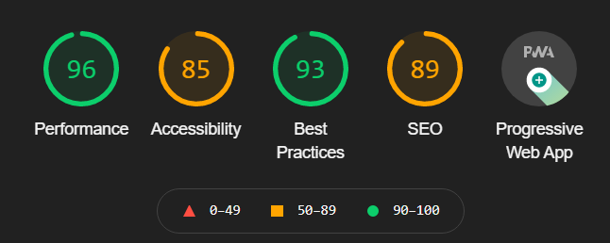

*Figure _ – Desktop Lighthouse test scores*

The desktop audit of the application resulted in an average score of 90 across all metrics. Suggestions for improving the score included improving contrast ratios for content in the background and foreground, language and meta attributes in the HTML tags etc. However, with a score of 90 or higher being deemed as a Good rating (i.e. not needing improvement), the desktop version of the application was deemed a success.

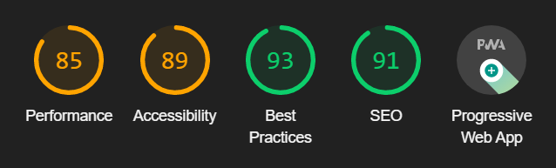

*Figure _ – Mobile Lighthouse test scores*

The mobile audit of the application resulted in an average score of 89 across all metrics. While scores for accessibility and search engine optimization rose, there was a significant downgrade in the performance score. This was largely down to render blocking resources in the code, along with unused JavaScript and CSS code. Apart from this, the scores on the desktop and mobile versions were very similar, and the mobile version was deemed a success, pending some minor tweaks on performance.

## 5.4. Conclusions

In this chapter, the testing and evaluation of the RentCommend system was presented. First, unit testing was discussed as the testing approach to be used in this project. Next, the Django test framework was identified as the testing framework for this application. A testing plan was then identified and implemented in the Unit Testing section. Following this, a discussion on user testing and evaluation occurred, mentioning how users drove the finished design of the application and assisted the error handling process.

A discussion into system evaluation then took place, with a focus on Google Lighthouse for automated auditing of a web page. The desktop and mobile version were both audited and deemed as successful.

# 6. Conclusions and Future Work

## 6.1. Introduction

This chapter presents how the development and testing process will be utilised as part of this project, along with a project plan to highlight key challenges ahead. The development section comprises of two sections, the first being work that had already been completed on the technical side and the challenges encountered when putting the prototype together. The second sub-section focuses on future development plans, the development environment, and an estimate on how long the development process will take. The testing section also comprises of two sub-sections. The first section covers the testing work done today including any testing plans that have been developed. The second section focuses on potential software testing libraries that could be used in the development environment, and the functionality it would be most important to test. Lastly, the project plan is presented accompanied by a GANTT chart.

## 4.4. Project Plan

In this section, the project plan is presented, with each key stage shown accompanied by an approximate duration for each stage.

The Development stage will begin in December and will run to approximately February. Testing will then begin in March and run to April, before the final submission. The project will then be evaluated for the two weeks before the final submission, making sure everything is running as intended and ironing out any last-minute bugs and errors. The process of documenting the project will occur over the course of the full year.

|  |  |  |  |  |  |  |  |  |  |  |  |  |  |  |  |  |  |  |  |  |  |  |  |  |  |  |  |  |  |  |  |  |  |  |  |  |  |  |  |  |  |  |
| --- | --- | --- | --- | --- | --- | --- | --- | --- | --- | --- | --- | --- | --- | --- | --- | --- | --- | --- | --- | --- | --- | --- | --- | --- | --- | --- | --- | --- | --- | --- | --- | --- | --- | --- | --- | --- | --- | --- | --- | --- | --- | --- |
|  | **September** | | | | **October** | | | | **November** | | | | | **December** | | | | | **January** | | | | | **February** | | | | | **March** | | | | | **April** | | | | | **May** | | | |
| **Initial**  **Proposal** |  |  |  |  |  |  |  |  |  |  |  |  |  | |  |  |  |  | |  |  |  |  | |  |  |  |  | |  |  |  |  | |  |  |  |  | |  |  |  | |
| **Requirements**  **Gathering** |  |  |  |  |  |  |  |  |  |  |  |  |  | |  |  |  |  | |  |  |  |  | |  |  |  |  | |  |  |  |  | |  |  |  |  | |  |  |  | |
| **Initial**  **Design** |  |  |  |  |  |  |  |  |  |  |  |  |  | |  |  |  |  | |  |  |  |  | |  |  |  |  | |  |  |  |  | |  |  |  |  | |  |  |  | |
| **Vertical**  **Prototype** |  |  |  |  |  |  |  |  |  |  |  |  |  | |  |  |  |  | |  |  |  |  | |  |  |  |  | |  |  |  |  | |  |  |  |  | |  |  |  | |
| **Interim**  **Report** |  |  |  |  |  |  |  |  |  |  |  |  |  | |  |  |  |  | |  |  |  |  | |  |  |  |  | |  |  |  |  | |  |  |  |  | |  |  |  | |
| **Interim**  **Demonstration** |  |  |  |  |  |  |  |  |  |  |  |  |  | |  |  |  |  | |  |  |  |  | |  |  |  |  | |  |  |  |  | |  |  |  |  | |  |  |  | |
| **Final**  **Design** |  |  |  |  |  |  |  |  |  |  |  |  |  | |  |  |  |  | |  |  |  |  | |  |  |  |  | |  |  |  |  | |  |  |  |  | |  |  |  | |
| **Implementation**  **Process** |  |  |  |  |  |  |  |  |  |  |  |  |  | |  |  |  |  | |  |  |  |  | |  |  |  |  | |  |  |  |  | |  |  |  |  | |  |  |  | |
| **Software**  **Testing** |  |  |  |  |  |  |  |  |  |  |  |  |  | |  |  |  |  | |  |  |  |  | |  |  |  |  | |  |  |  |  | |  |  |  |  | |  |  |  | |
| **Project**  **Evaluation** |  |  |  |  |  |  |  |  |  |  |  |  |  | |  |  |  |  | |  |  |  |  | |  |  |  |  | |  |  |  |  | |  |  |  |  | |  |  |  | |
| **Dissertation**  **Document** |  |  |  |  |  |  |  |  |  |  |  |  |  | |  |  |  |  | |  |  |  |  | |  |  |  |  | |  |  |  |  | |  |  |  |  | |  |  |  | |
| **Final**  **Demonstration** |  |  |  |  |  |  |  |  |  |  |  |  |  | |  |  |  |  | |  |  |  |  | |  |  |  |  | |  |  |  |  | |  |  |  |  | |  |  |  | |

## 

## 4.5. Conclusions

This chapter discussed the direction in which this project is heading. It focused on what has been done so far in terms of development, prototyping and testing, and the plans for the months ahead. The testing aspect was also presented, discussing the testing plans and the plan for automating tests. Lastly, a project plan was presented in the form of a GANTT chart.

# Bibliography

MacNamee, G. (2018). *The national average rent is €1,122 per month – it’s an extra €500 if you live in the capital.* [online] TheJournal.ie. Available at: <https://www.thejournal.ie/rental-prices-income-4390977-Dec2018/> [Accessed 15 Dec. 2020].

Harris, J. (2018). *30000 empty homes and nowhere to live: inside Dublin’s housing crisis.* [online] The Guardian. Available at: <https://www.theguardian.com/cities/2018/nov/29/empty-dublin-housing-crisis-airbnb-homelessness-landlords> [Accessed 15 Dec. 2020].

Sullivan, P. and Mcguckin, R. (2018). *The Private Rented Sector in Ireland AIB Real Estate Finance.* [online]. Available at: <https://aib.ie/content/dam/aib/corporate/docs/real-estate-finance/aib-private-rented-sector-report-august-2018.pdf> [Accessed 15 Dec. 2020].

Lima, V. (2019). *Towards an understanding of the regional impact of Airbnb in Ireland. Regional Studies, Regional Science,* 6(1),pp.78-91.

O’Grady, S. (2020). *The RedMonk Programming Language Rankings: June 2020.* [online] tecosystems. Available at: <https://redmonk.com/sogrady/2020/07/27/language-rankings-6-20/> [Accessed 15 Dec. 2020].

Openstreetmap.org. (n.d). *About | OpenStreetMap Blog.* [online] Available at: <https://blog.openstreetmap.org/about/> [Accessed 15 Dec. 2020].

Postgis.net. (n.d). *9. Geometries – Introduction to PostGIS.* [online] Available at: <http://postgis.net/workshops/postgis-intro/geometries.html> [Accessed 15 Dec. 2020].

Vaughan-Nichols, S.J. (2018). *What is Docker and why is it so darn popular?* [online] ZDNet. Available at: <https://redmonk.com/sogrady/2020/07/27/language-rankings-6-20/> [Accessed 15 Dec. 2020].

Docker. (2019). *Why Docker? | Docker.* [online] Available at: <https://www.docker.com/why-docker> [Accessed 15 Dec. 2020].

DigitalOcean. (n.d). *Droplets – Scalable Virtual Machines | DigitalOcean.* [online] Available at: <https://www.digitalocean.com/products/droplets/> [Accessed 15 Dec. 2020].

Nielsen, J. (1994) *Usability engineering. Amsterdam: Morgan Kaufmann.*

The Interaction Design Foundation. (n.d). *What is User Centred Design?* [online] Available at: <https://www.interaction-design.org/literature/topics/user-centered-design#:~:text=User%2Dcentered%20design%20(UCD),and%20accessible%20products%20for%20them>.) [Accessed 15 Dec. 2020].

Jacko, J.A. (2003). *Human-Computer Interaction: Theory and Practise (part 1), Volume 1.* CRC Press.

International Organisation for Standardization (1999). *Human-centred design processes for interactive systems.*

Daniels, N., Sheahan, J. and MacNeela, P. (2019). *Variables affecting first-year college student commitment during the transition to college in Ireland.* Health Promotion International.

Higher Education Authority. (2017). *Report on Student Accomodation: Demand and Supply.* [online]. Available at: <https://hea.ie/assets/uploads/2017/06/Report-on-Student-Accommodation-Demand-Supply.pdf> [Accessed 15 Dec. 2020].

Martin, J.S., Hébert, M., Ledoux, É., Gaudreault, M. and Laberge, L. (2012). *Relationship of Chronotype to Sleep, Light Exposure, and Work-Related Fatigue in Student Workers.* Chronobiology International, 29(3), pp.295-304.

Base36.com. (2013). *Agile & Waterfall Methodologies – A Side-By-Side Comparison | IT Staffing & Technical Consulting.* [online] Available at: <http://www.base36.com/2012/12/agile-waterfall-methodologies-a-side-by-side-comparison/> [Accessed 15 Dec. 2020].

Forsberg, K. and Mooz, H. (1991). *The Relationship of System Engineering to the Project Cycle.* Center for Systems Management.

Muslihat, D. (2018). *Agile Methodology: An Overview.* [online] Available at: <https://zenkit.com/en/blog/agile-methodology-an-overview/> [Accessed 15 Dec. 2020].

Gour, R. (2019). *Working Structure of Django MTV Architecture.* [online] Available at: <https://towardsdatascience.com/working-structure-of-django-mtv-architecture-a741c8c64082> [Accessed 15 Dec. 2020].

Selenium. (n.d). *Quick tour :: Documentation for Selenium* [online] Available at: <https://www.selenium.dev/documentation/en/getting_started/quick/> [Accessed 15 Dec. 2020].

*final submission*

wiki.openstreetmap.org. (n.d.). *Overpass API - OpenStreetMap Wiki*. [online] Available at: [https://wiki.openstreetmap.org/wiki/Overpass_API#:~:text=The%20Overpass%20API%20(formerly%20known](https://wiki.openstreetmap.org/wiki/Overpass_API%23:~:text=The%20Overpass%20API%20(formerly%20known%20) [Accessed 15 Mar. 2021].

speakingjs.com. (n.d.). *Chapter 4. How JavaScript Was Created*. [online] Available at: [http://speakingjs.com/es5/ch04.html](http://speakingjs.com/es5/ch04.html%20) [Accessed 15 Mar. 2021].

w3techs.com. (2021). *Usage Statistics of JavaScript as Client-side Programming Language on Websites, February 2020*. [online] Available at: <https://w3techs.com/technologies/details/cp-javascript/> [Accessed 15 Mar. 2021].

Otto, M. (2011). *Bootstrap from Twitter*. [online] blog.twitter.com. Available at: [https://blog.twitter.com/developer/en_us/a/2011/bootstrap-twitter.html](https://blog.twitter.com/developer/en_us/a/2011/bootstrap-twitter.html%20) [Accessed 15 Mar. 2021].

docs.djangoproject.com. (n.d.). *Writing your first Django app, part 5 | Django documentation | Django*. [online] Available at: <https://docs.djangoproject.com/en/3.1/intro/tutorial05/> [Accessed 15 Mar. 2021].

www.guru99.com. (n.d.). *Unit Testing Tutorial: What is, Types, Tools, EXAMPLE*. [online] Available at: [https://www.guru99.com/unit-testing-guide.html#:~:text=UNIT%20TESTING%20is%20a%20type,an%20application%20by%20the%20developers.](https://www.guru99.com/unit-testing-guide.html%23:~:text=UNIT%20TESTING%20is%20a%20type,an%20application%20by%20the%20developers.)

Google Developers. (2019). *Lighthouse  |  Tools for Web Developers  |  Google Developers*. [online] Available at: [https://developers.google.com/web/tools/lighthouse/.](https://developers.google.com/web/tools/lighthouse/)